JOBSHEET 2

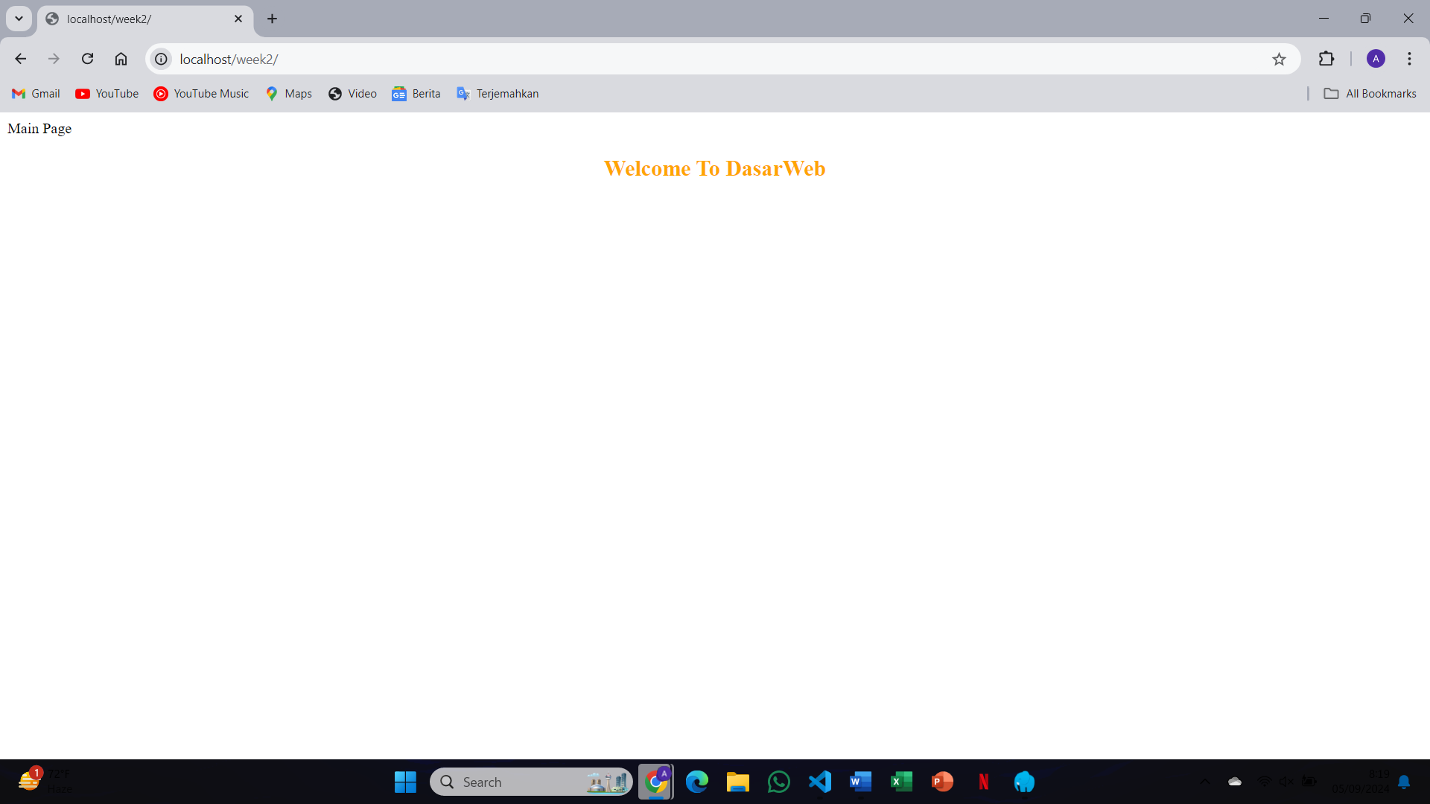

1. 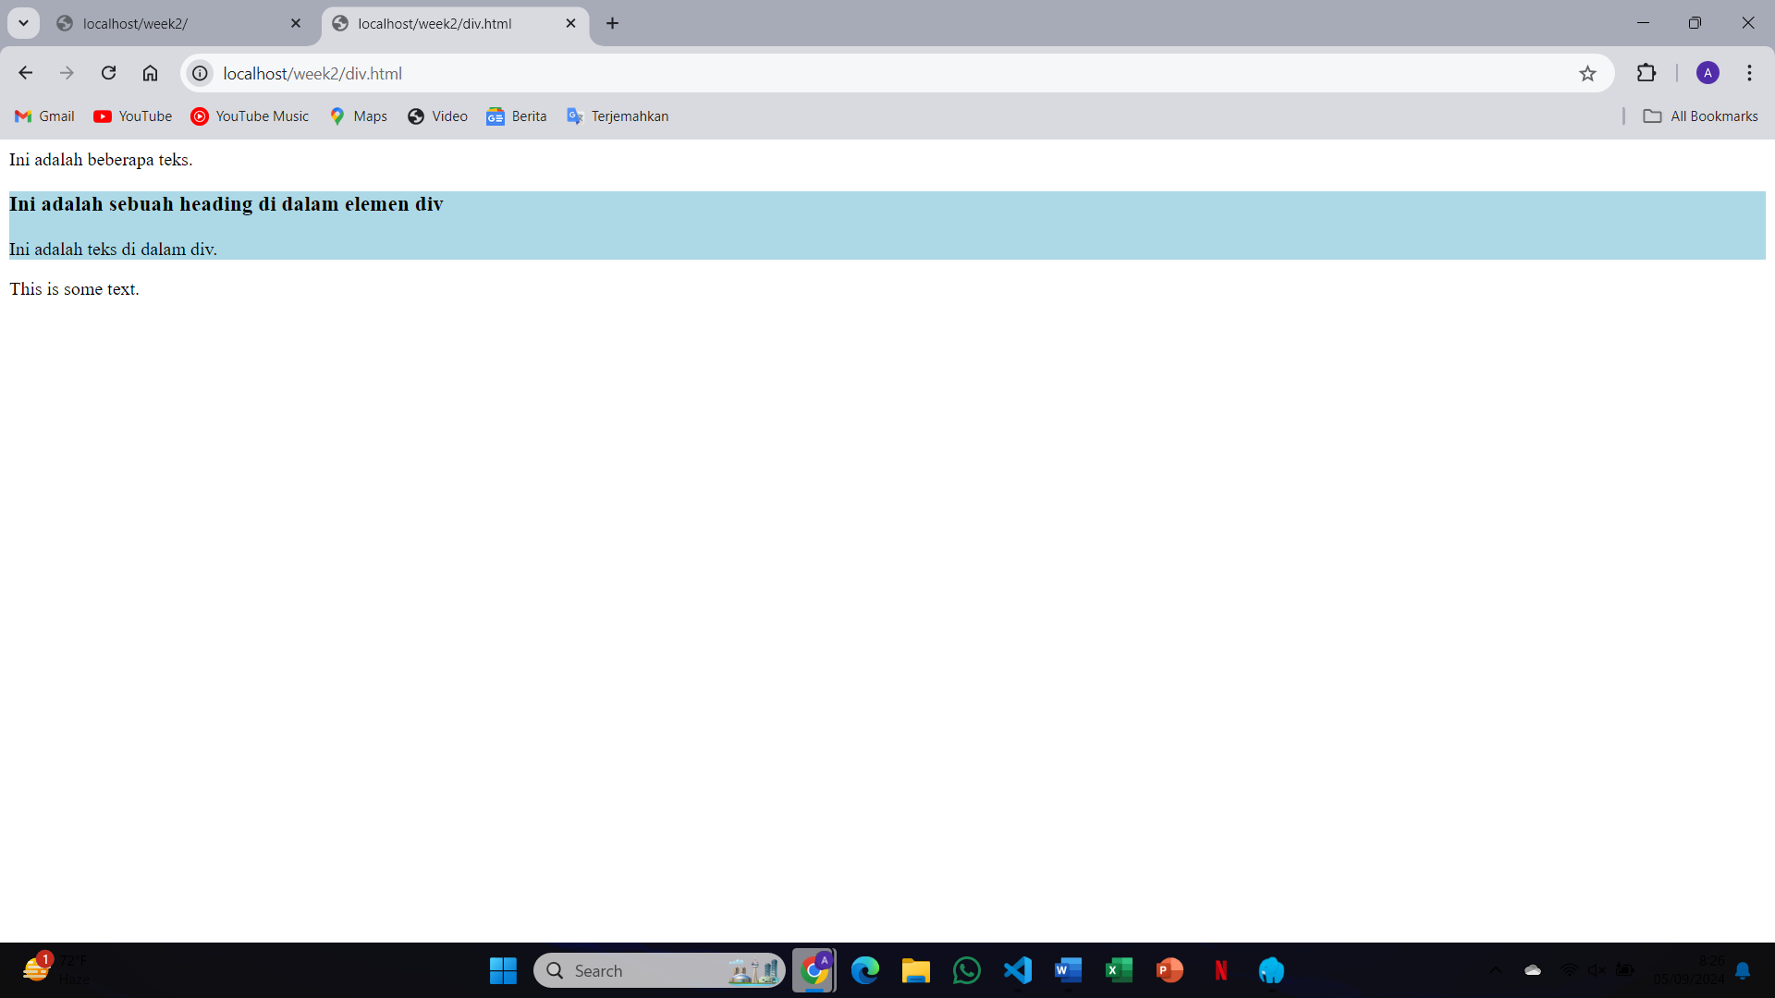The <div> tag defines a section in an HTML document. The <div> element is often used as a container for other HTML elements to add styles with CSS or to display specific tasks using JavaScript
2. 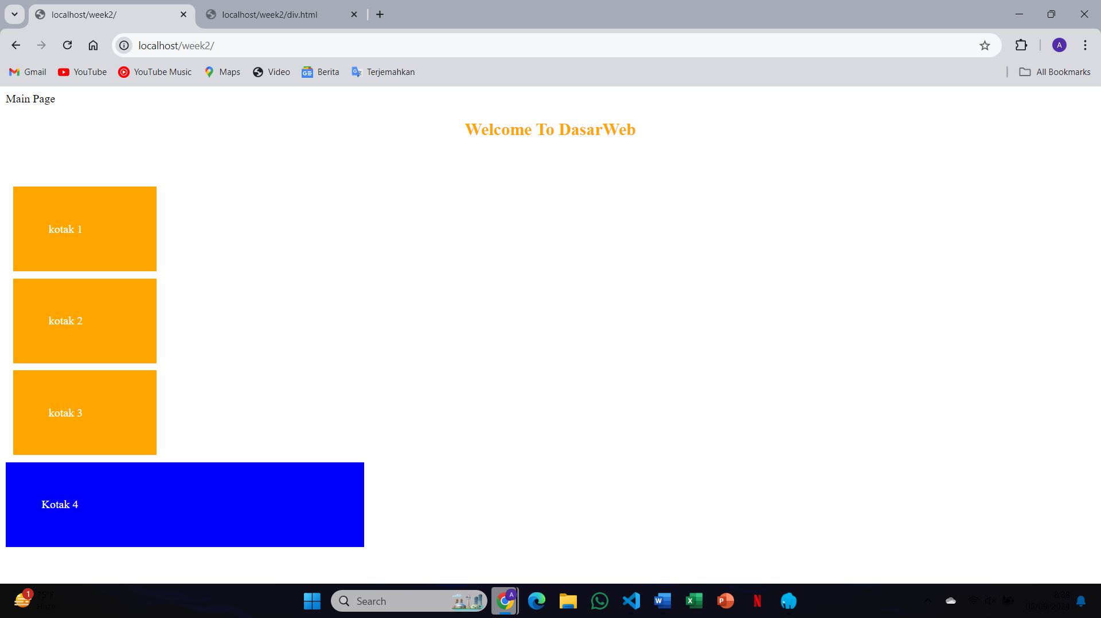

The difference between class and id is that the class is called on css or javascript using a "period".", and the id is called on CSS or javascript with the hashtag "#". The advantages of class is the class can be given to many HTML elements and can be called at once, while ID can only work on one tag, meaning one ID name can only be given to one element

1. 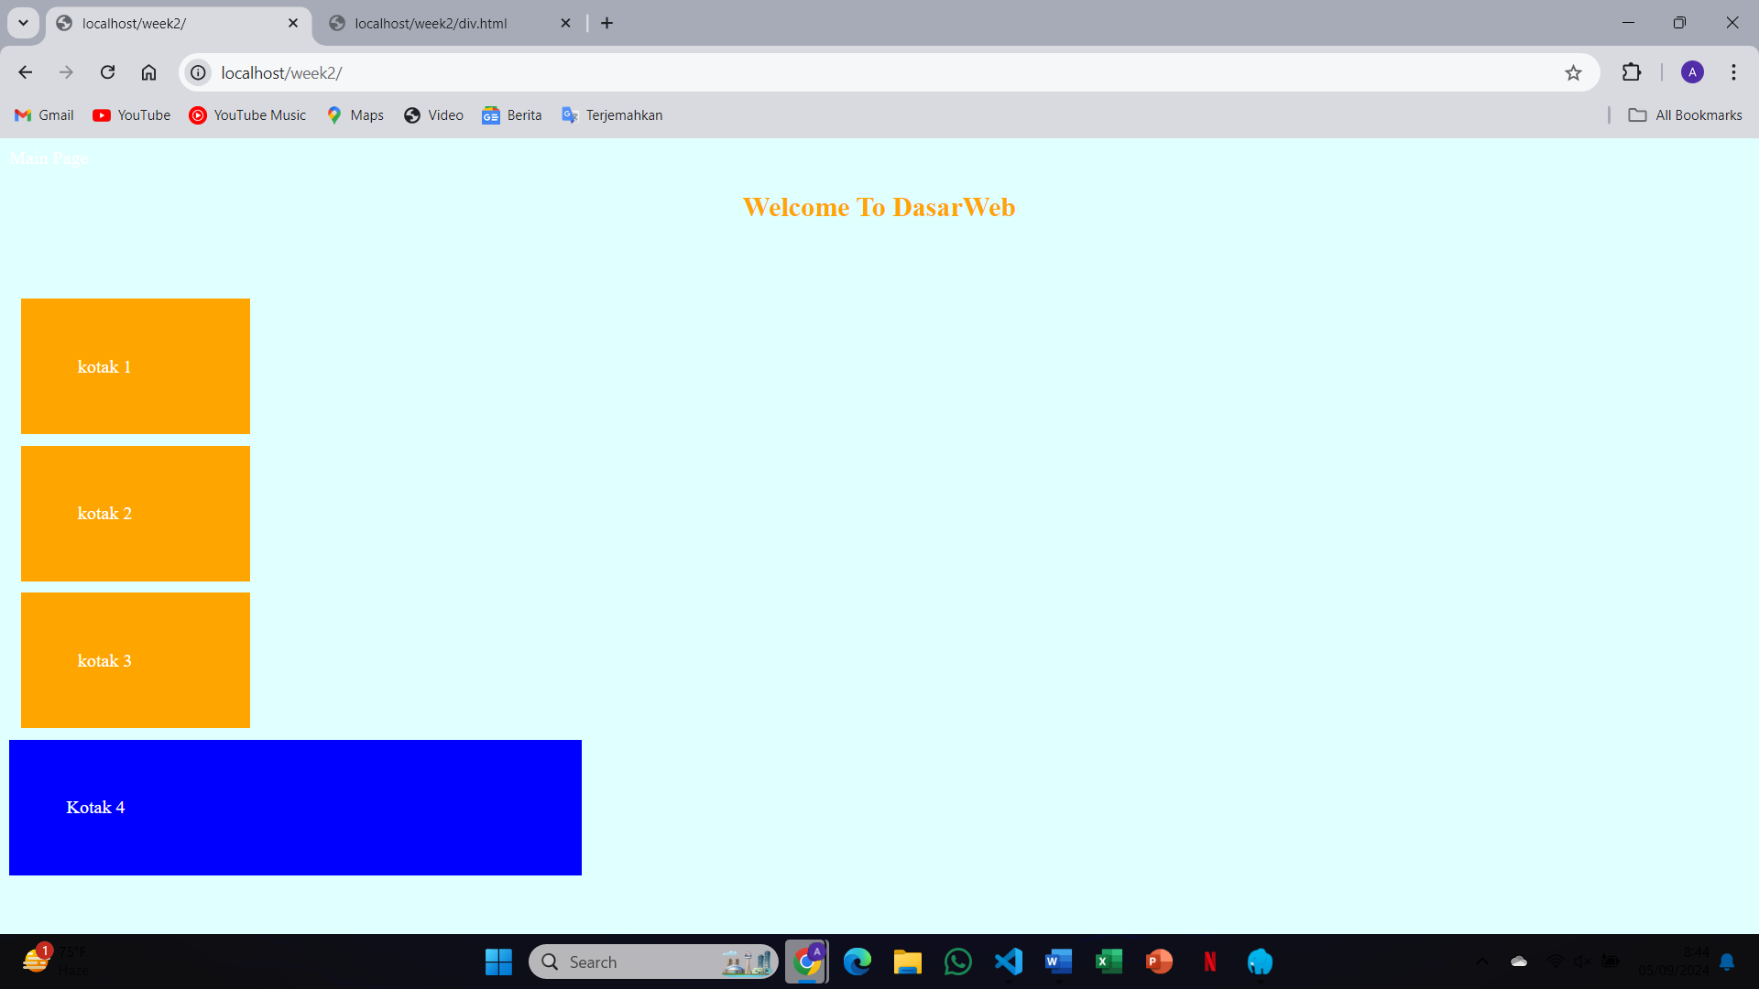Setting a background color changes the appearance of the entire web page or specific sections. The web page’s background will turn light blue, creating a visually distinct page
2. 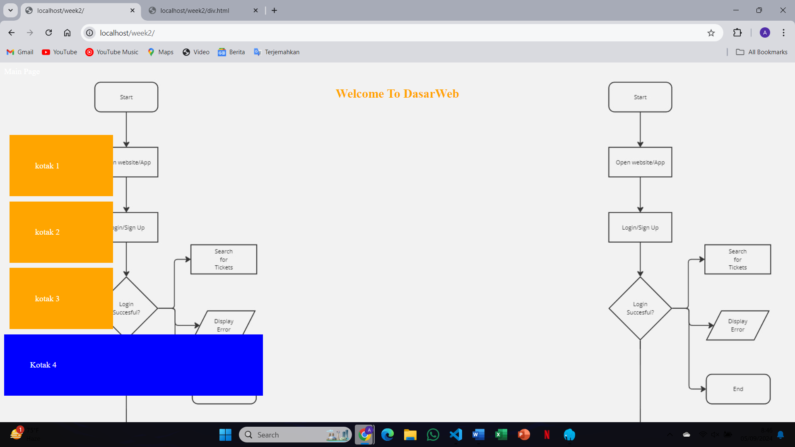When setting an image as the background, the image will repeat by default if it’s smaller than the viewport
3. 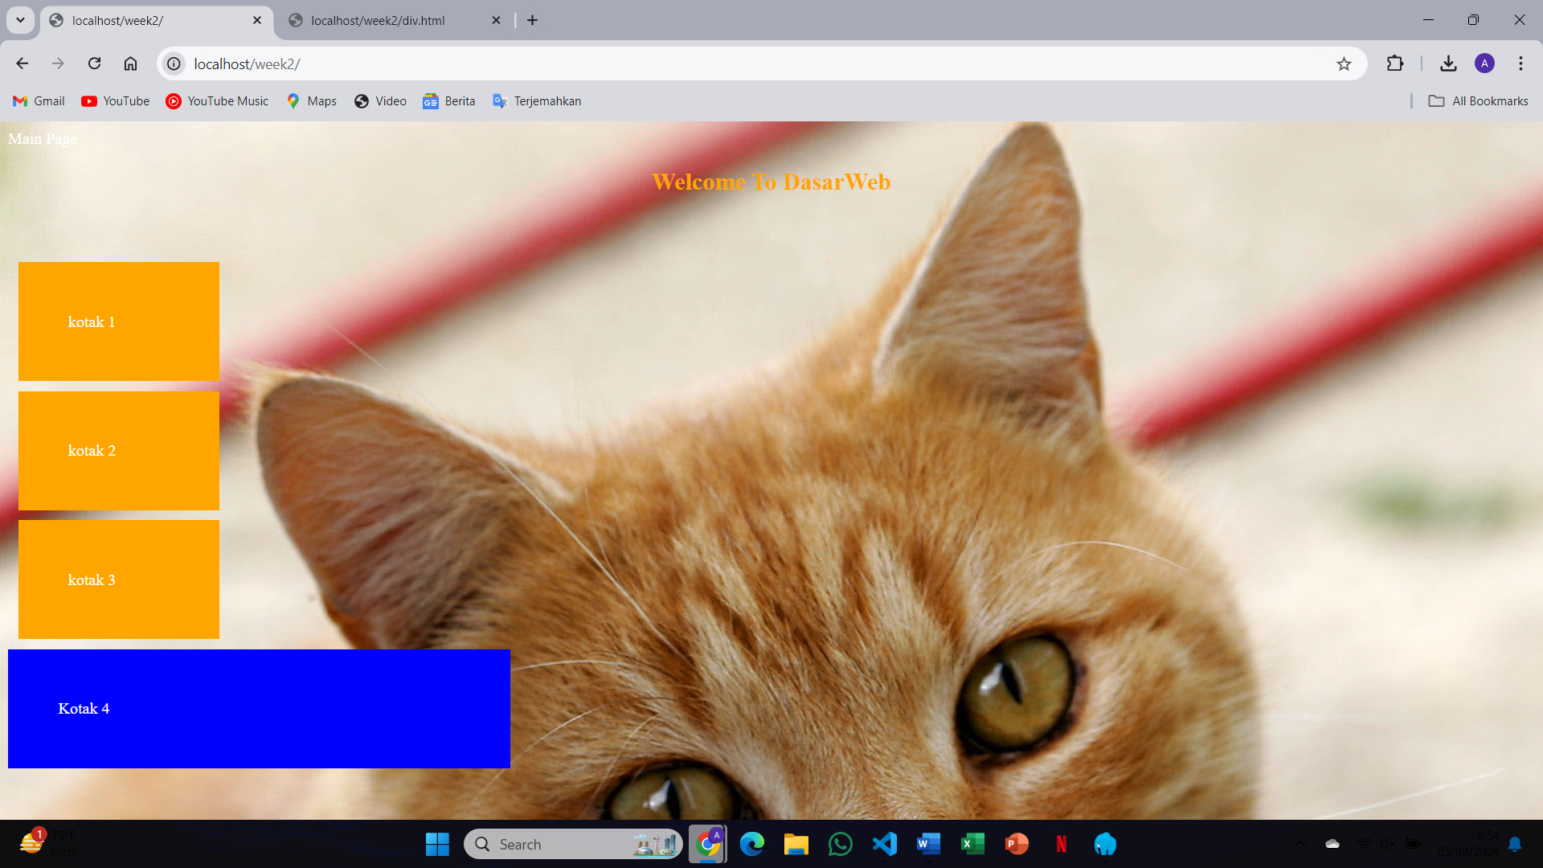You can control this behavior using properties like background-repeat: no-repeat; or background-size: cover; to prevent tiling and ensure it covers the entire page
4. 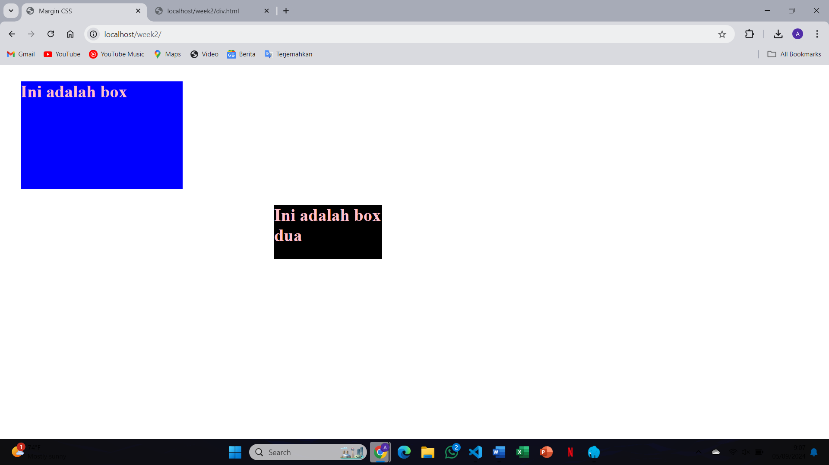Margins create space outside the element’s border, padding creates space inside the element’s border, between the content and the border itself
5. 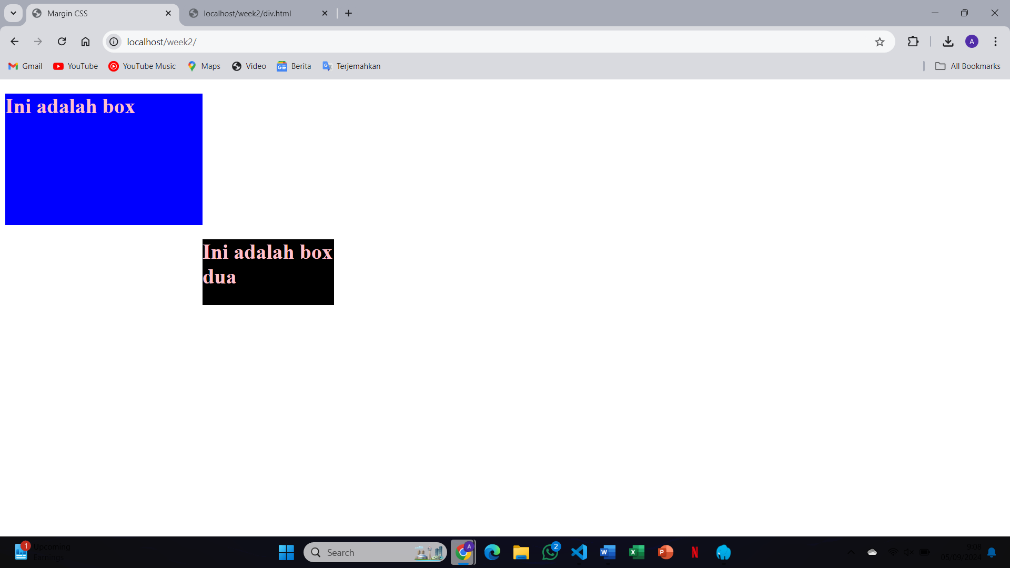Changing the margin to 300px creates a large amount of space around the element. The element is pushed far away from the surrounding content, giving it more separation from other elements on the page
6. 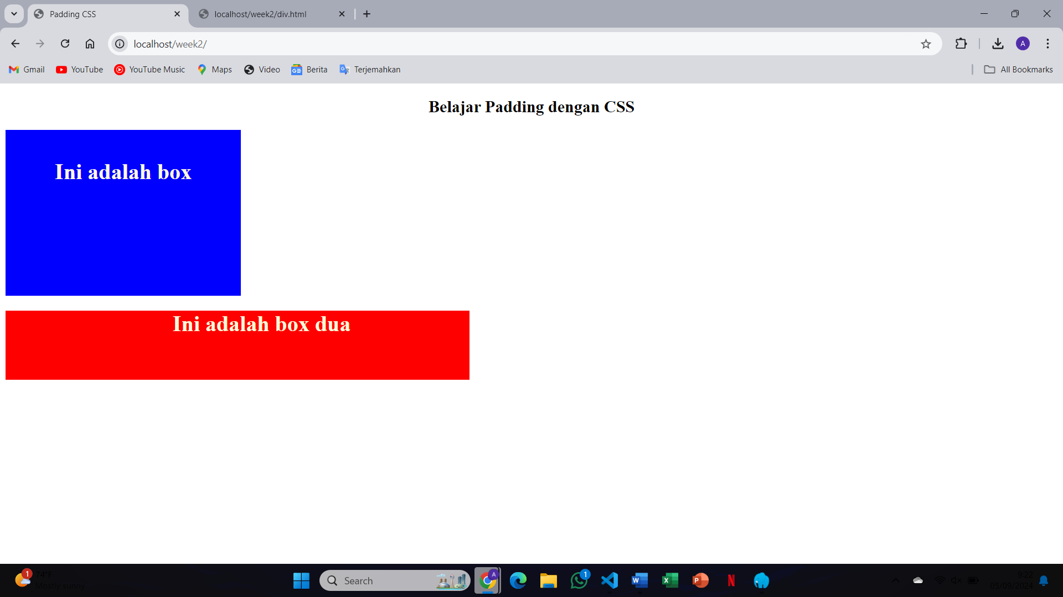The padding of 200px increases the space between the content and the element’s border, making the element appear much larger because the content is pushed inward, away from the edges
7. 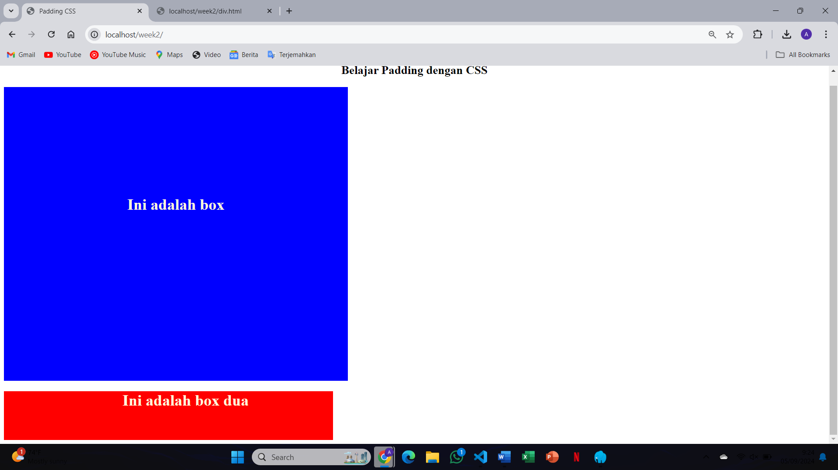Changing the font settings, such as font-size, font-family, font-weight, and color, alters the appearance of the text, making it larger, changing its style (e.g., bold or italic), and affecting its readability and visual impact
8. 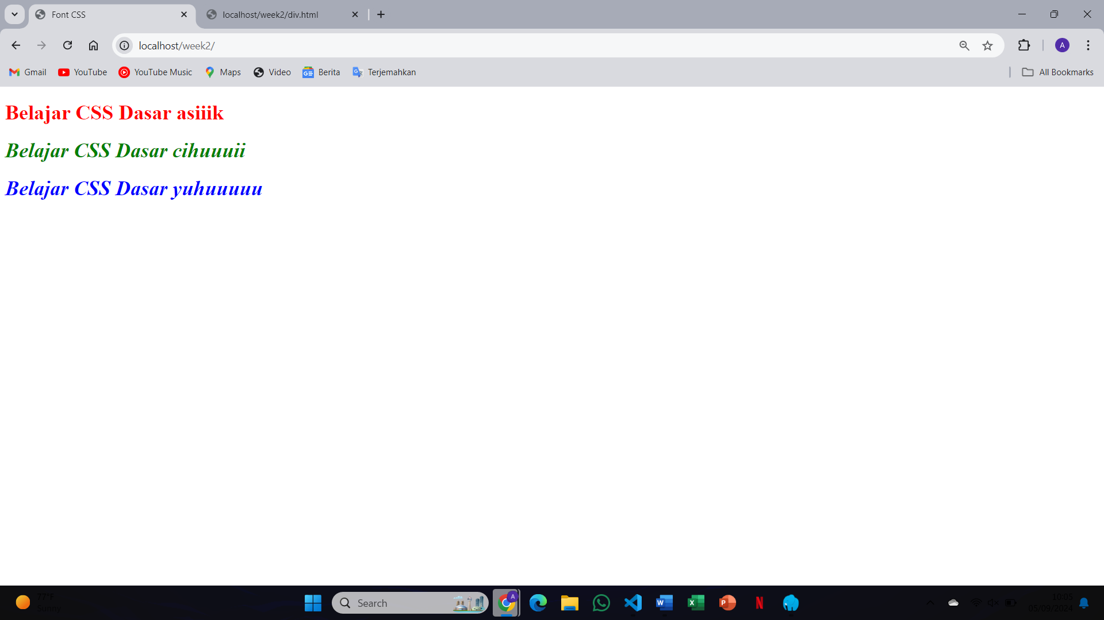The paragraph text becomes larger, bold, and uses the Arial font. Adjusting these settings changes the readability and visual appearance of the text
9. 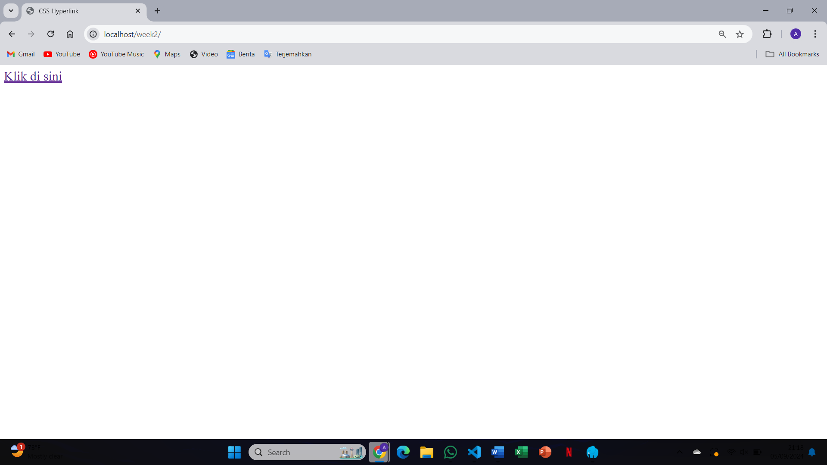Different styles can be applied to different hyperlink states (a:link, a:hover, a:visited, a:active). For instance, the hover state changes the link’s appearance when you move the mouse over it. This improves user interaction by providing visual feedback
10. 

* link : visited {

color: greenyellow;

}

* The visited state (a:visited) changes the color of links that have been clicked, providing a visual distinction between visited and unvisited links. This is useful for user navigation

1. 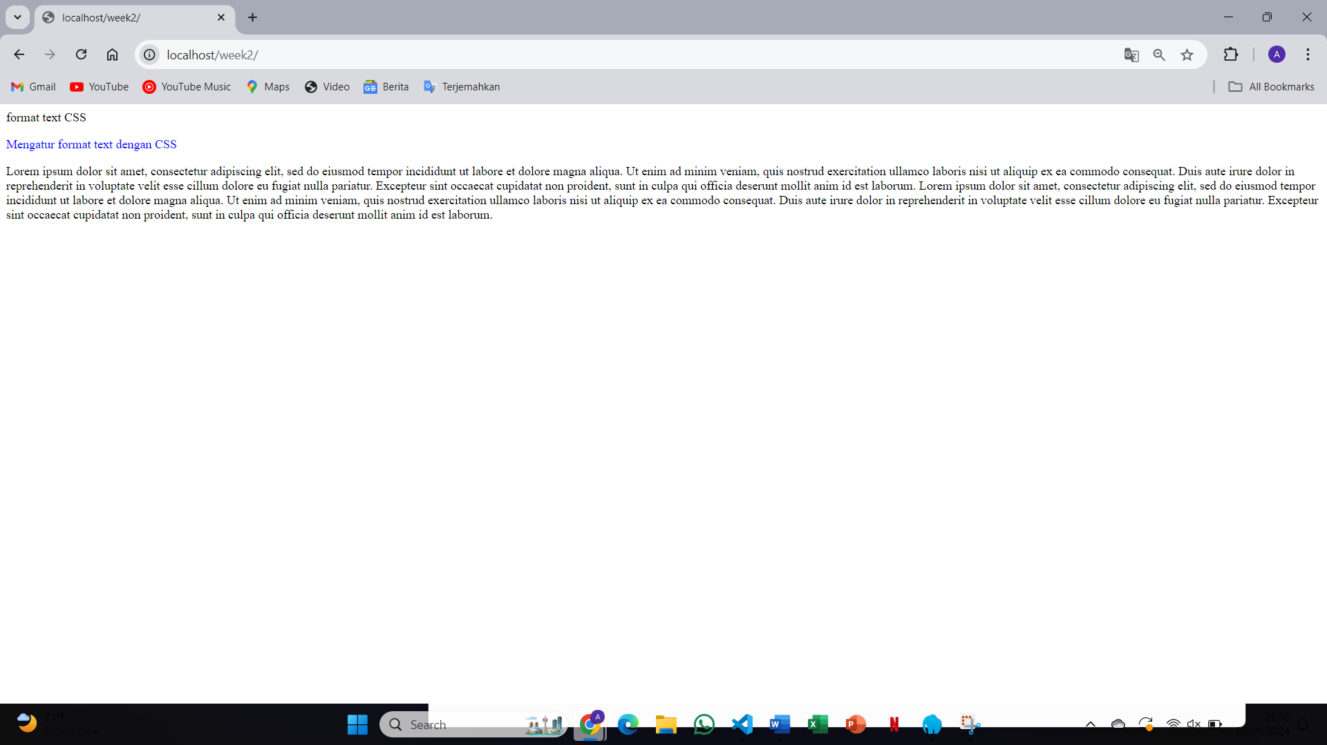After changing the position of the text using CSS with properties like position: relative, absolute, or fixed, the text moves based on the specified top, left, right, or bottom values, altering its placement within the page layout, and affecting how other elements interact with it
2. 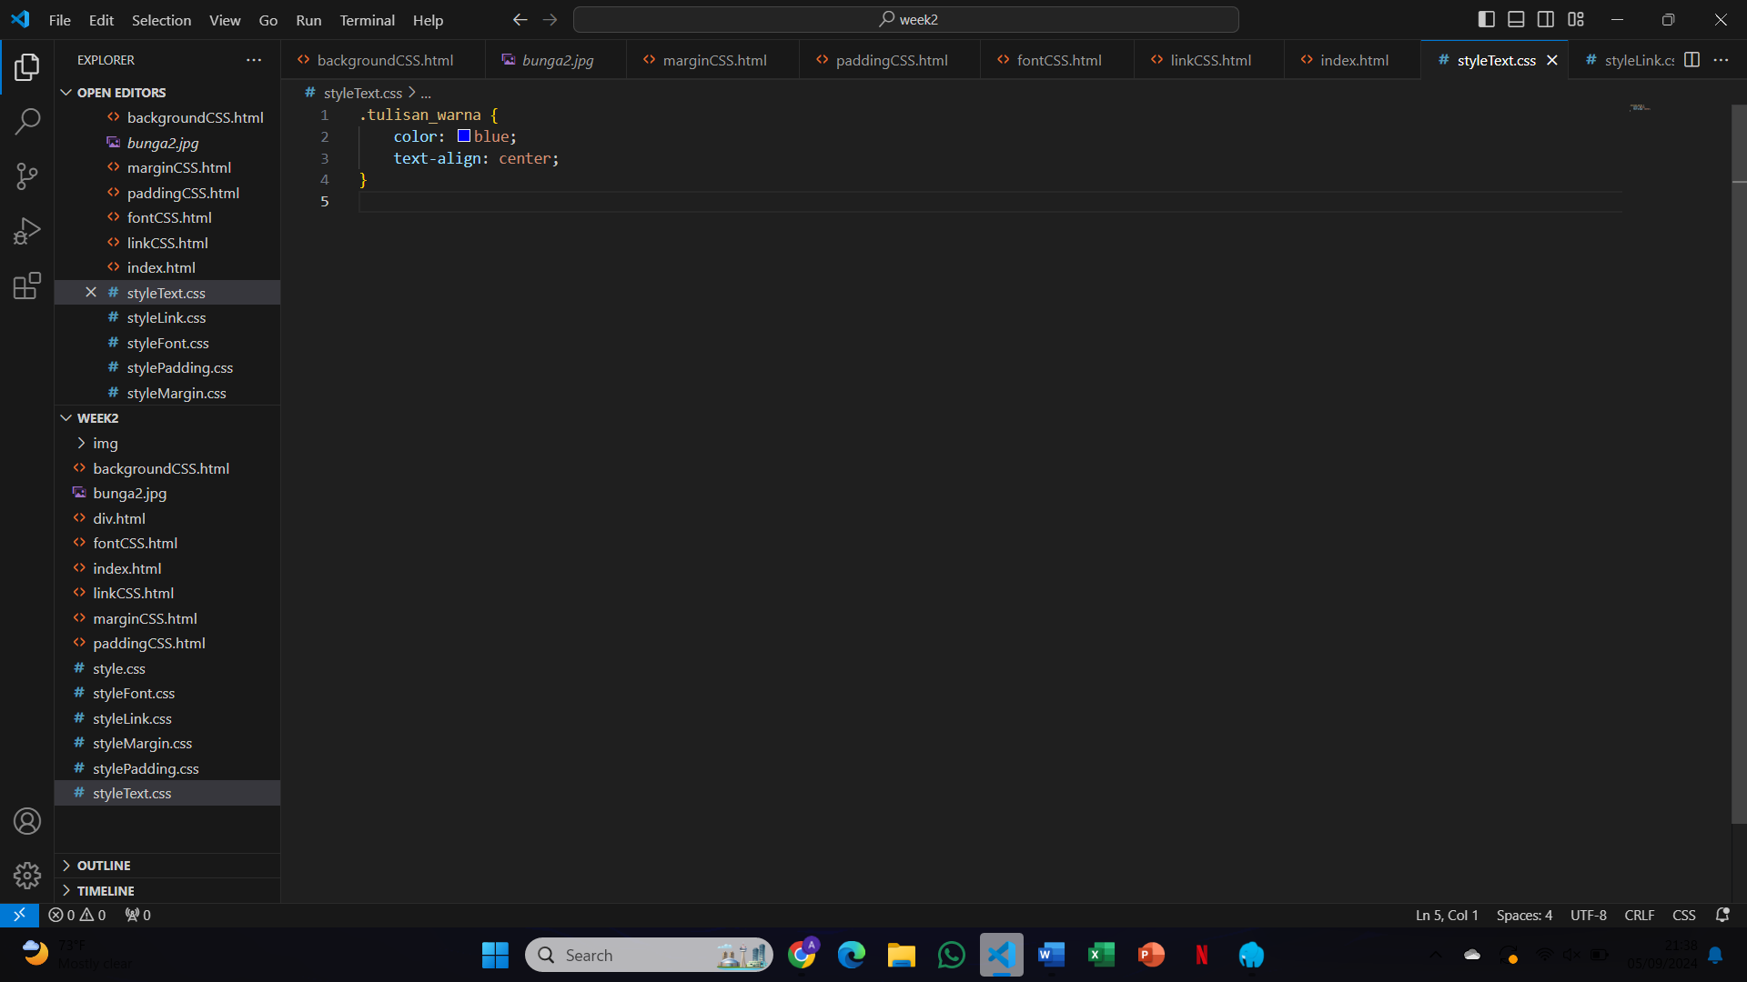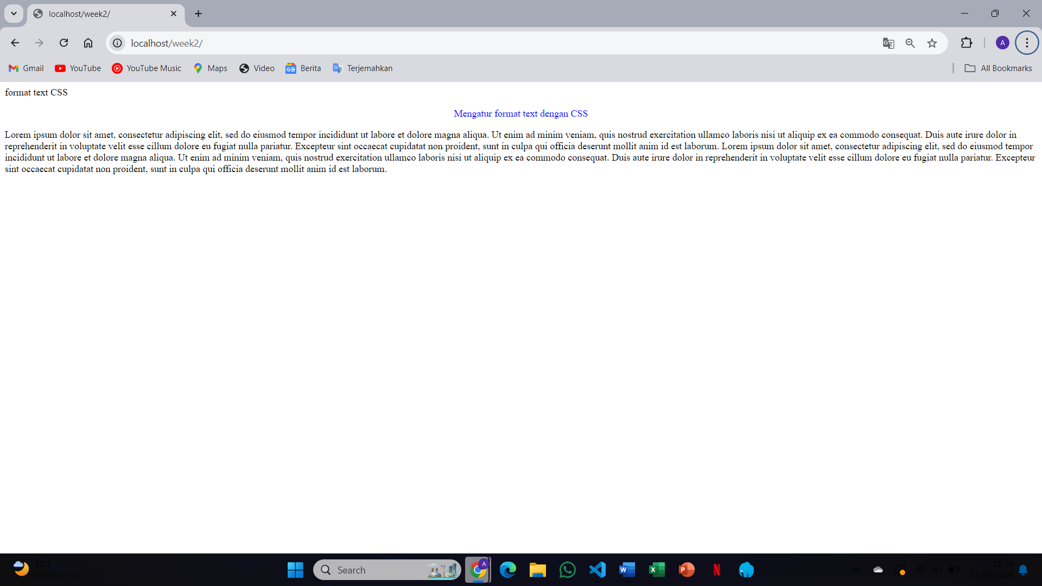When using text-align: center;, the text is centered within its containing element, providing a balanced appearance. Adding other properties, such as text-decoration: underline;, adds an underline to the text
3. 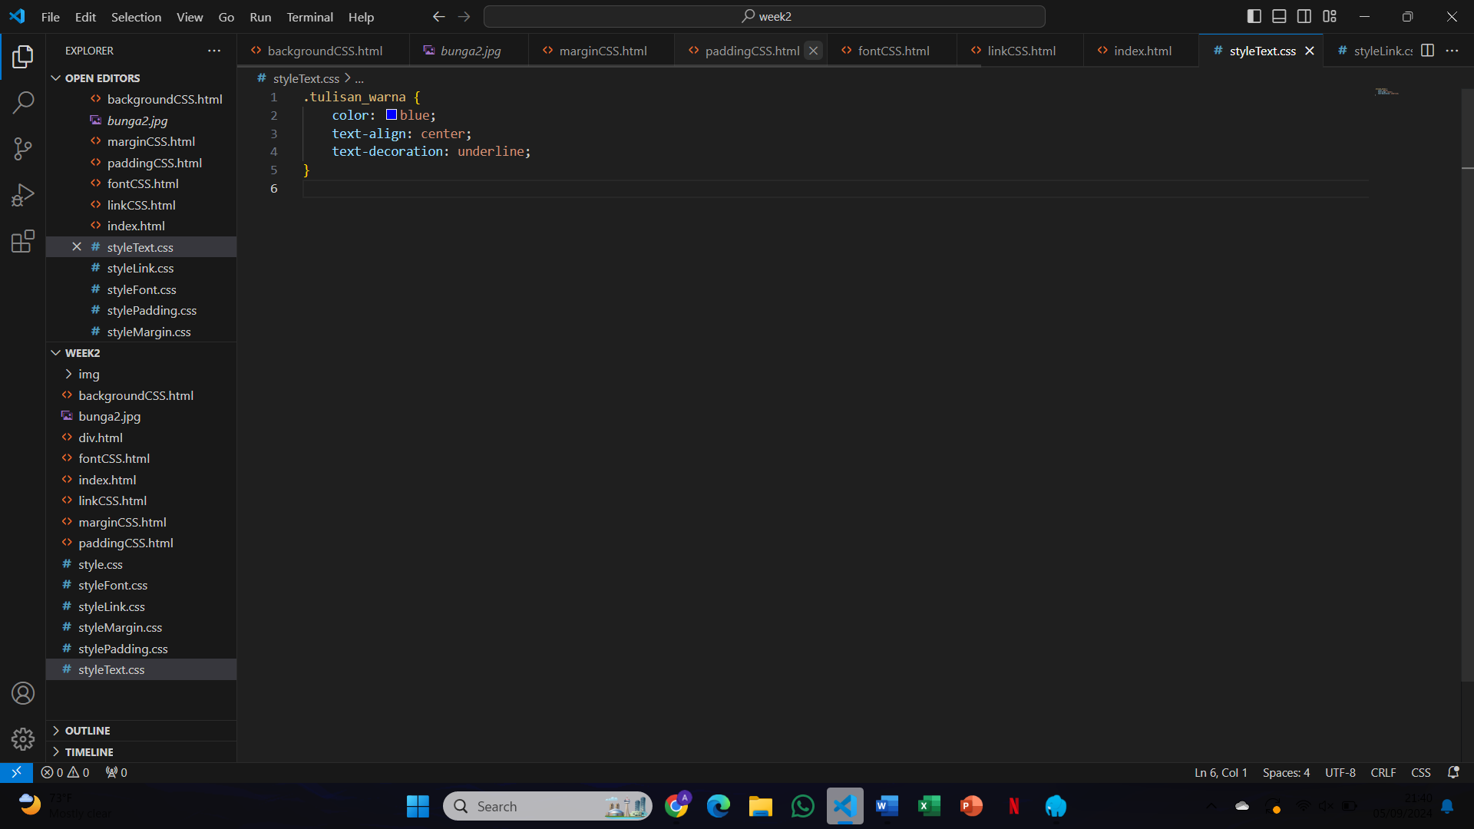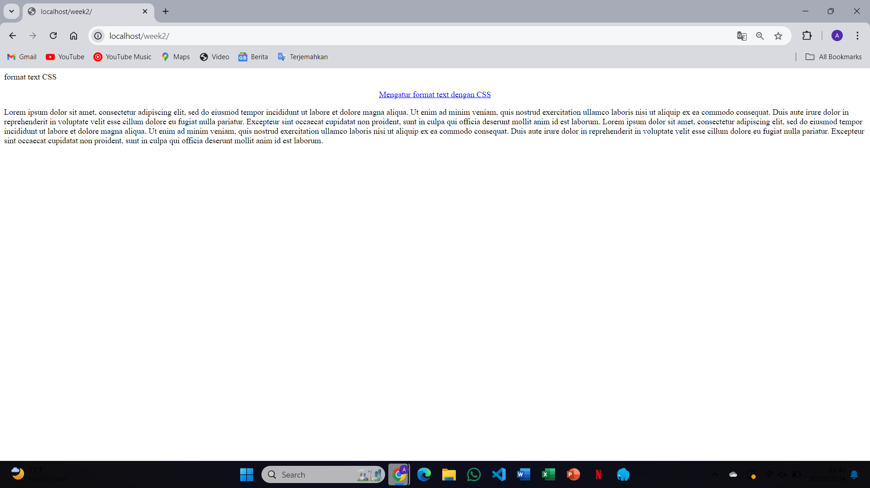

* Adding other properties, such as text-decoration: underline;, adds an underline to the text
* {

text-decoration: underline;

}

1. 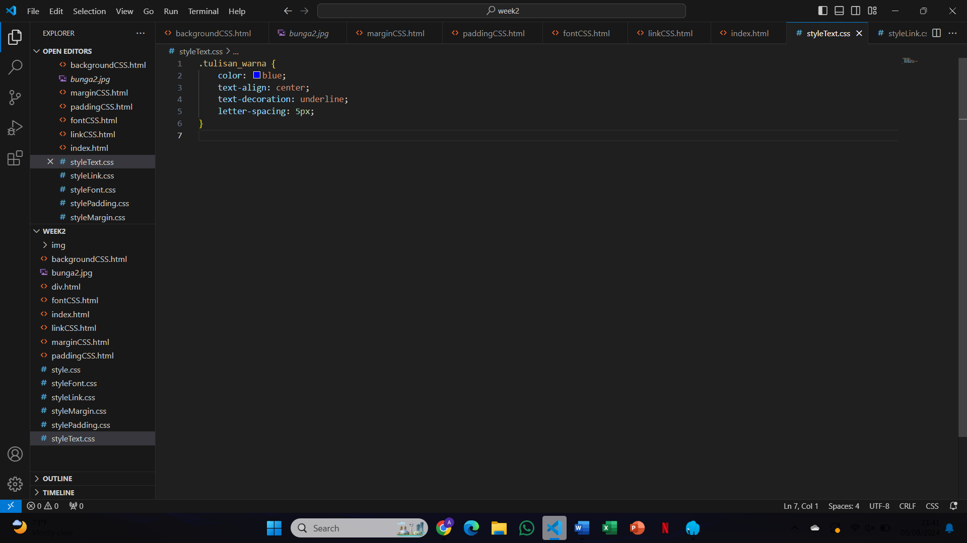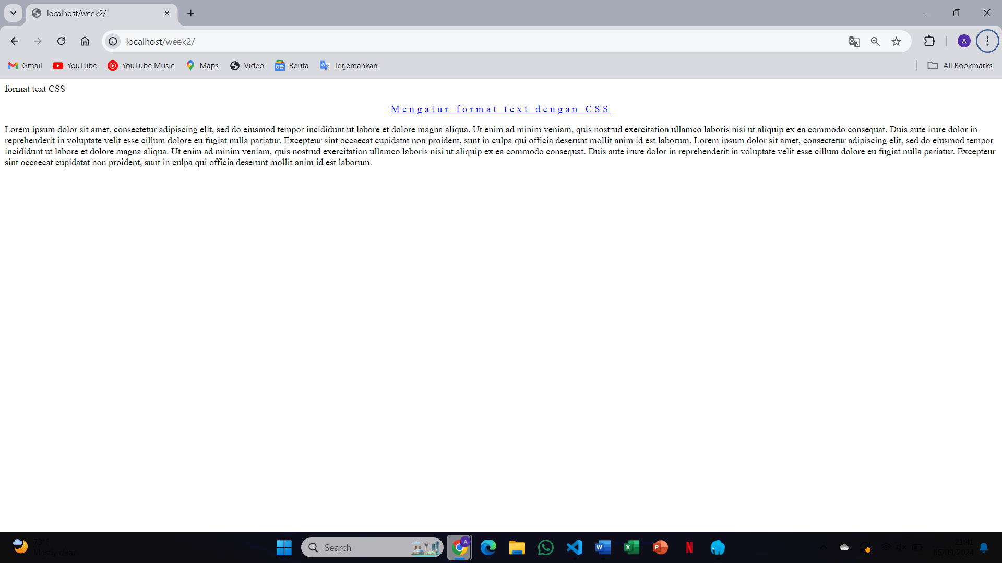

* {

letter-spacing: 5px;

}

1. 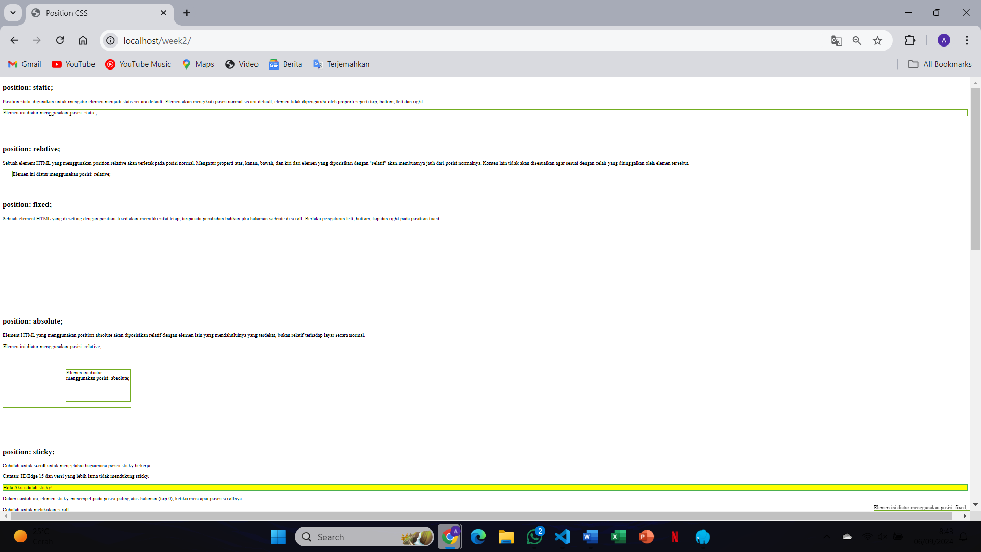When using the position property (e.g., static, relative, absolute, fixed, or sticky), the positioning of elements changes relative to the browser window, the parent container, or the element's normal flow, which can affect how the element overlaps or moves on the page
2. 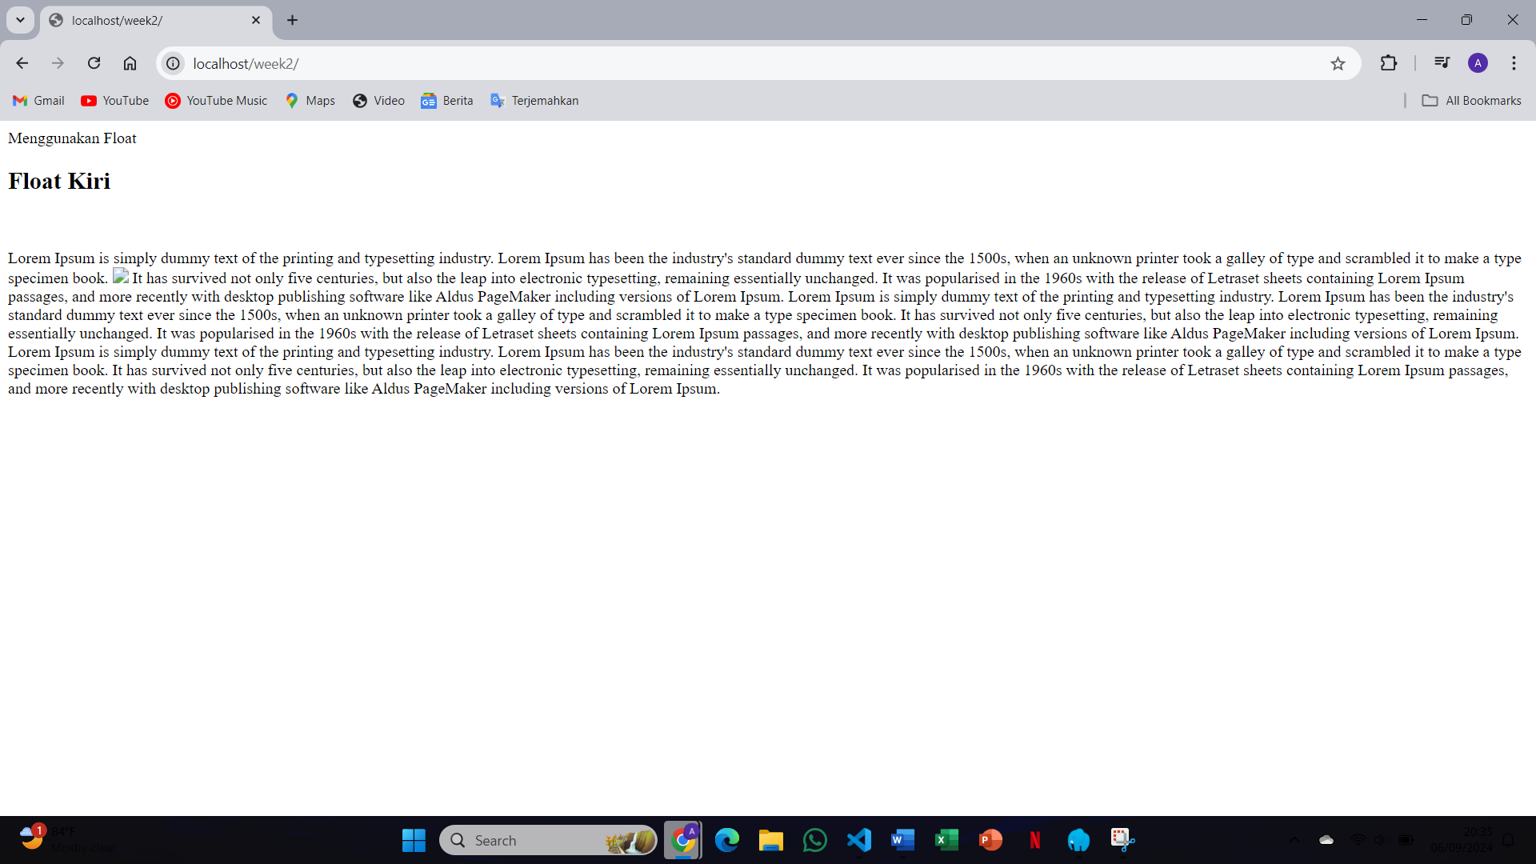Using the float property (float: left; or float: right;), elements such as images or divs are positioned to the left or right of their container, with text or other inline elements wrapping around them
3. 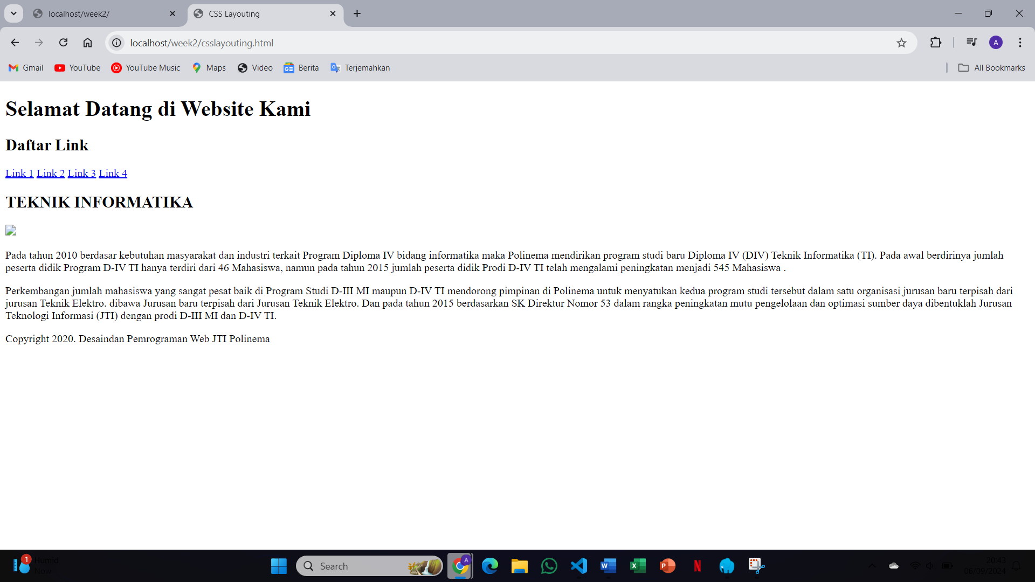

The difference is that `inline` elements stay on the same line without controlling width/height, while `block` elements take up the full width and start on a new line, allowing full control over dimensions

1. 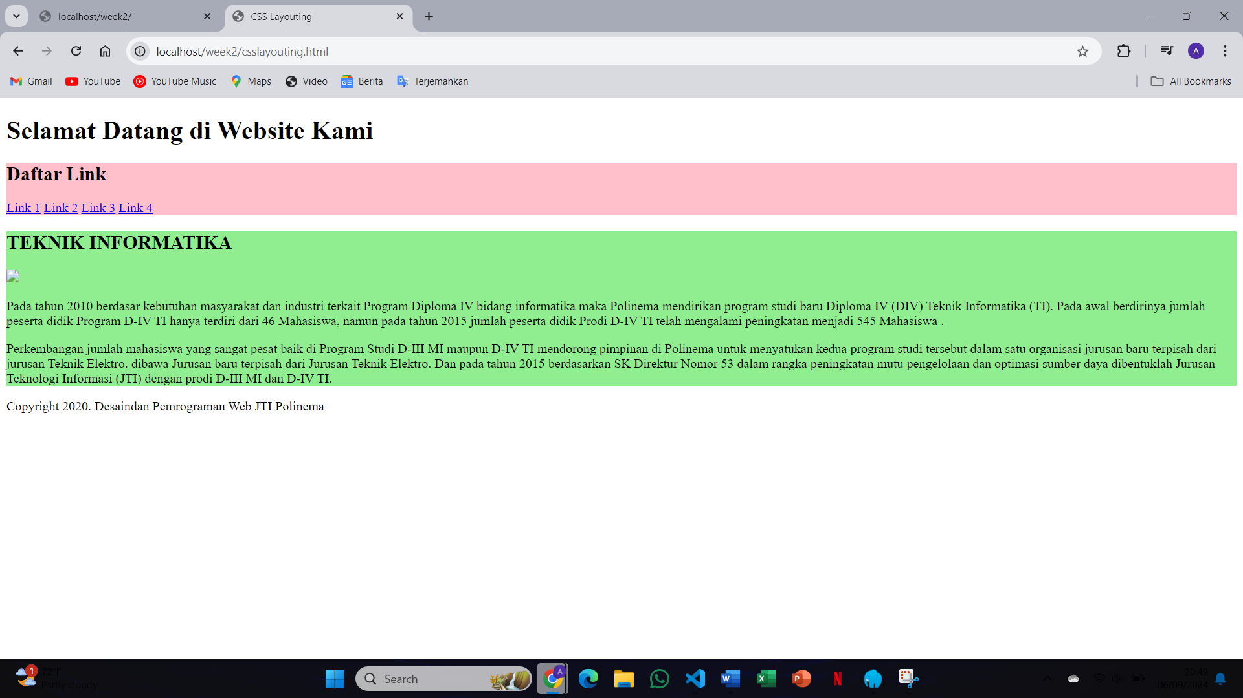When styles are applied to the navigation class and the main class, you would observe that the navigation section (likely a menu or list of links) adopts the new styles, such as width, background color, or alignment. The main section will also reflect the changes based on the applied CSS, possibly affecting layout, padding, margins, or positioning
2. 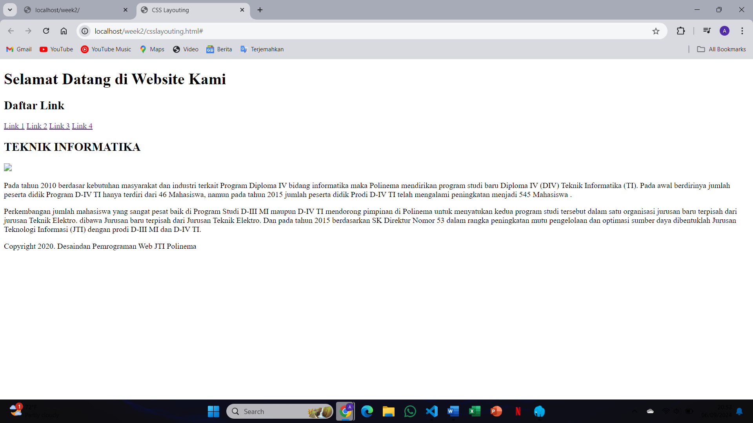After adding 5 links and running the code, the links are displayed on the same line because elements with display: inline; do not start on a new line. The links will adjust and fit horizontally in a row, continuing to wrap only when the available width is exceeded, but their width and height cannot be controlled directly
3. 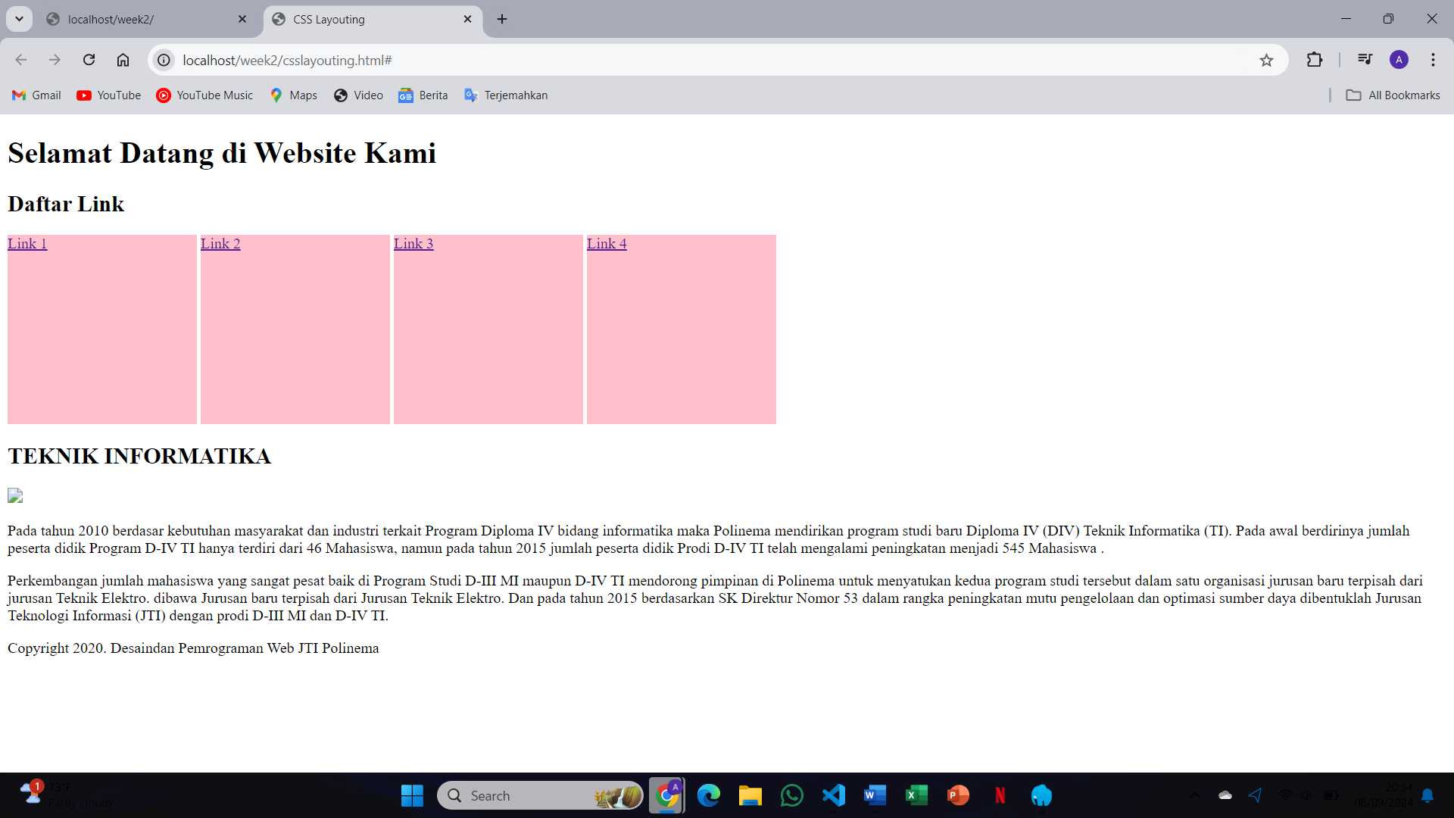After applying display: inline-block to the links and setting width and height, the links behave like block elements in that you can control their size, but they still remain in the same line like inline elements, allowing for layout flexibility while maintaining inline positioning
4. 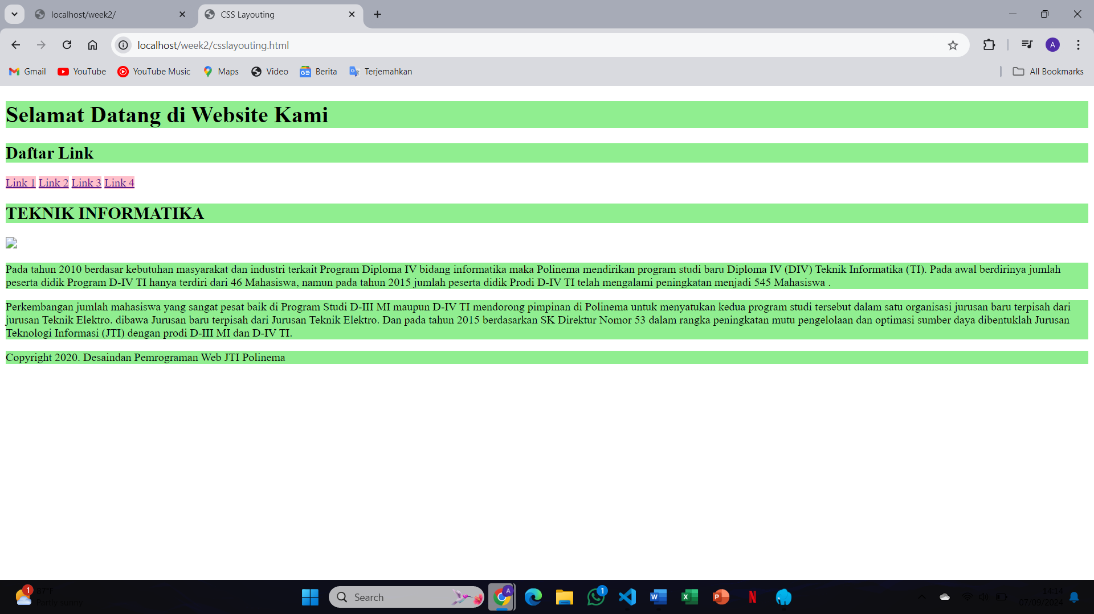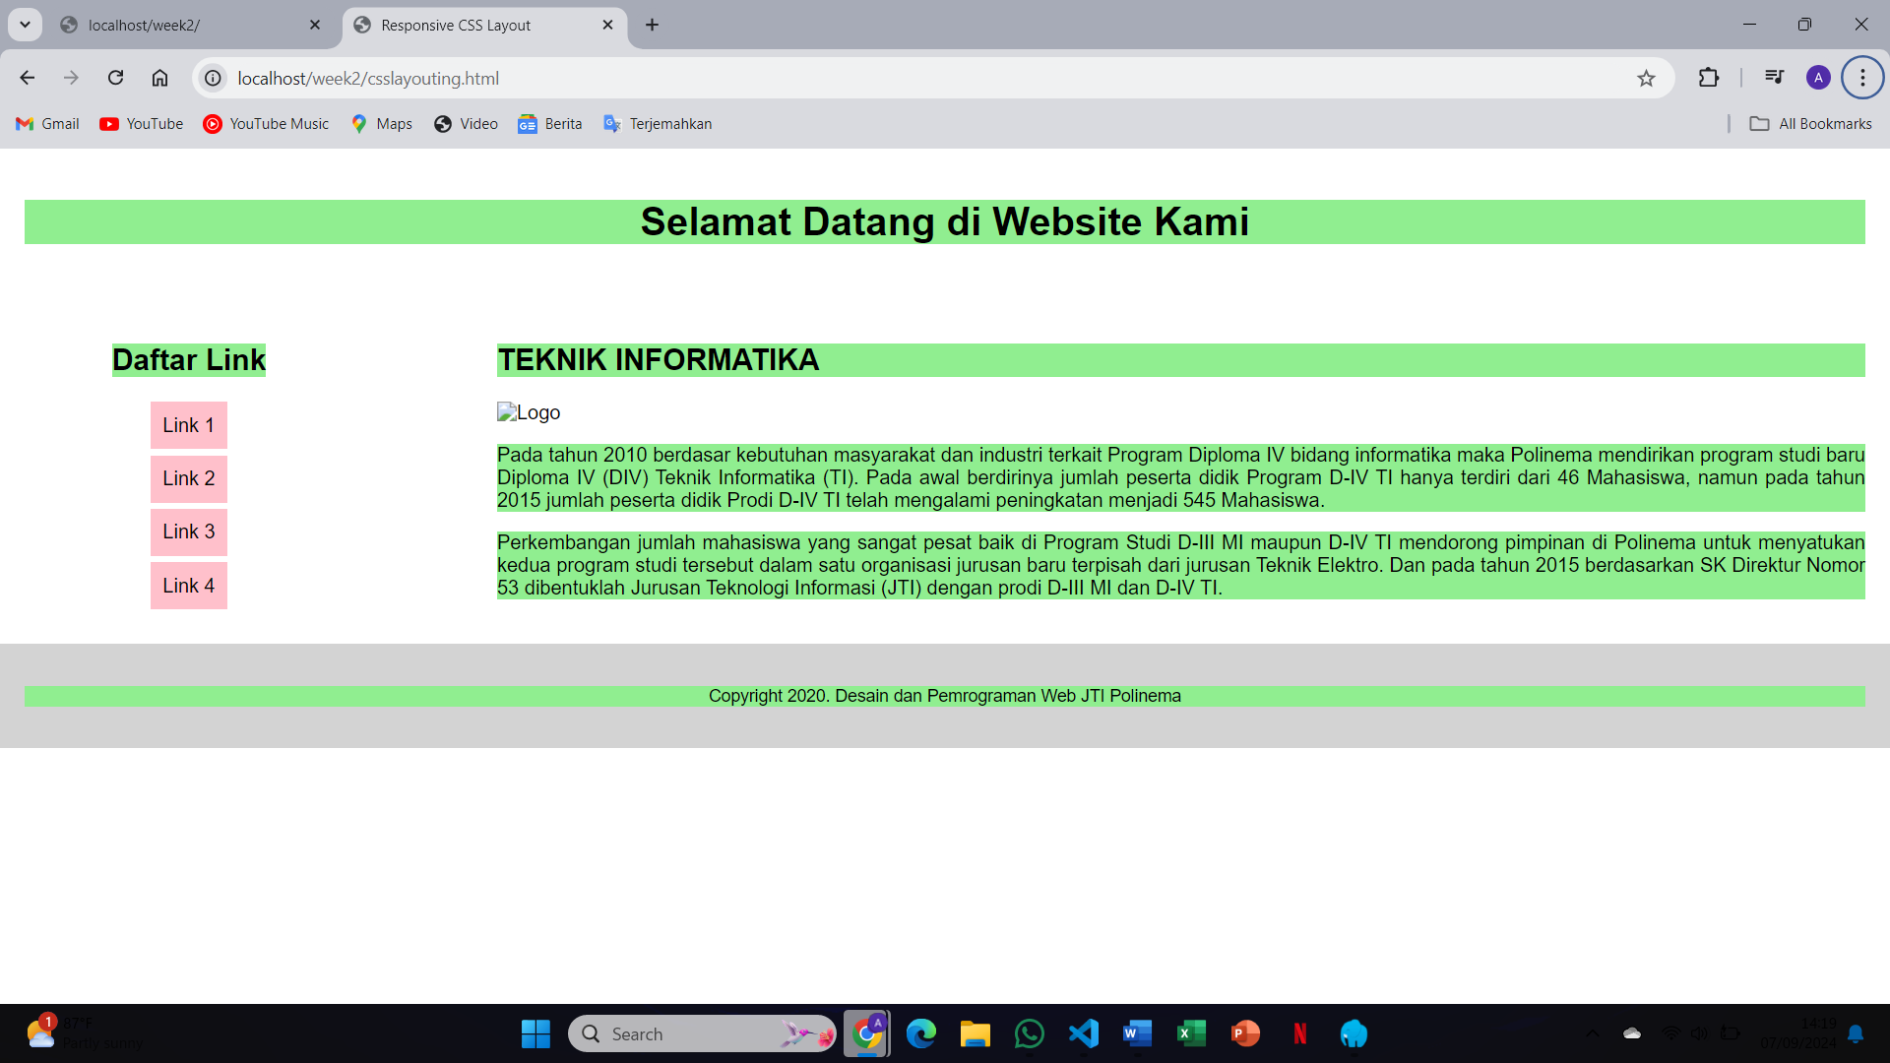After styling the h1, h2, and p elements with a light-green background and resizing the web page, the block elements (h1, h2, p) maintain their full-width behavior, expanding or contracting to fill the width of the container, and each element remains stacked vertically with no change in their block-level behavior
5. 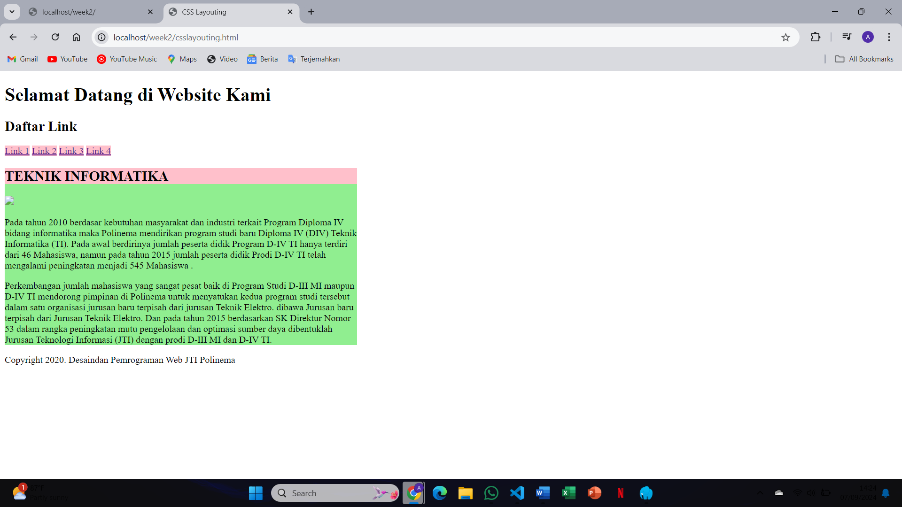After adding a style to the main class and running the program, the main section adjusts according to the specified styles (such as background color, width, padding, etc.), and the content inside the main section is displayed as a block-level element, expanding to take up the full width of its container while maintaining its vertical stacking behavior
6. 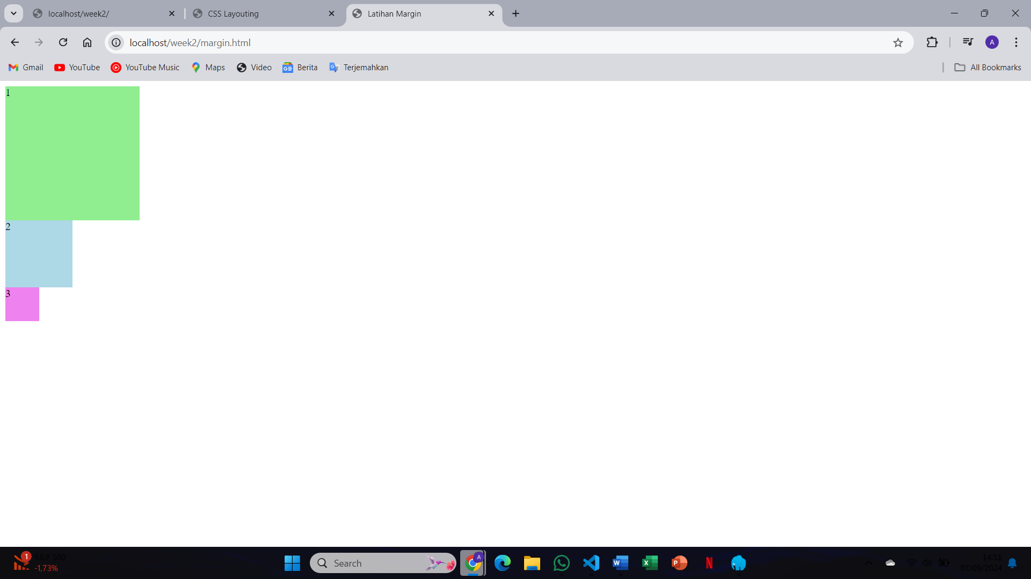After running the margin.html program, you would observe that the margins create space outside the element's border, pushing the element away from surrounding elements, resulting in visually distinct gaps or spacing between elements, depending on the margin values set in the CSS
7. 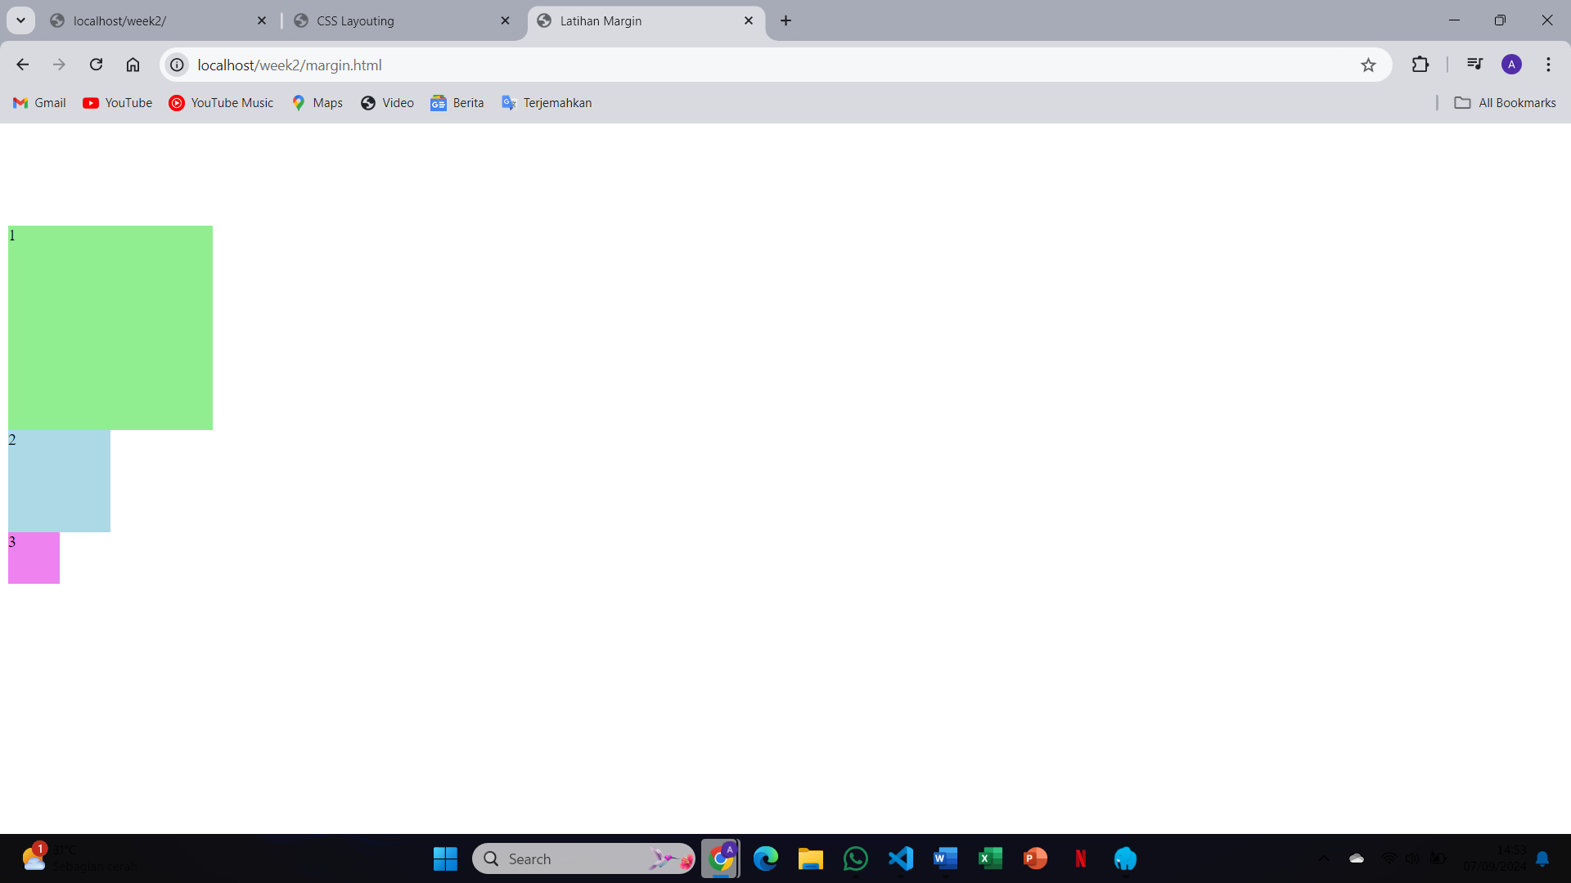After setting a margin-top of 100px to the .satu class and running the program, the element with the class .satu is pushed down by 100px from the top of its container, creating a large gap above it, while the other margins (left, right, and bottom) remain unaffected unless they are explicitly set
8. 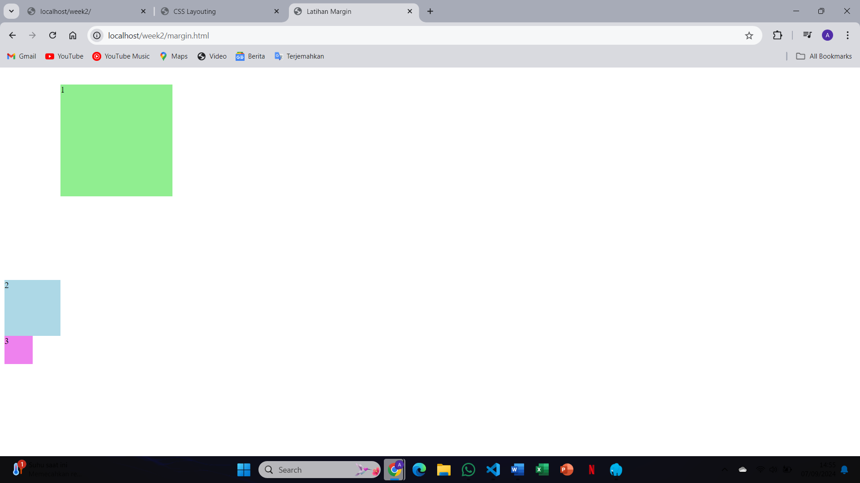After adding different margin sizes and running the program, the elements are positioned with varying amounts of space around them, depending on the margin values. Larger margins create more space between the element and its surrounding content, while smaller margins reduce that space, resulting in a different layout and spacing between elements on the page
9. 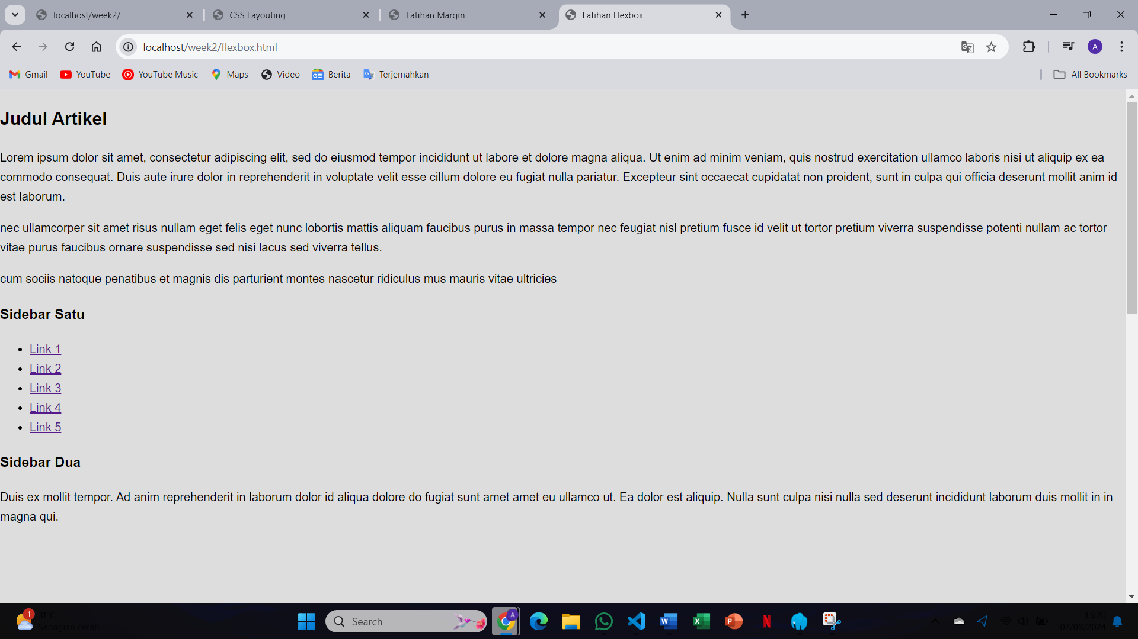After running the flexbox.html program, the elements inside the flex container are aligned and distributed according to the flexbox properties. The items automatically adjust their size and position within the container based on the available space, aligning either in rows or columns, depending on the specified flex-direction and justify-content settings
10. 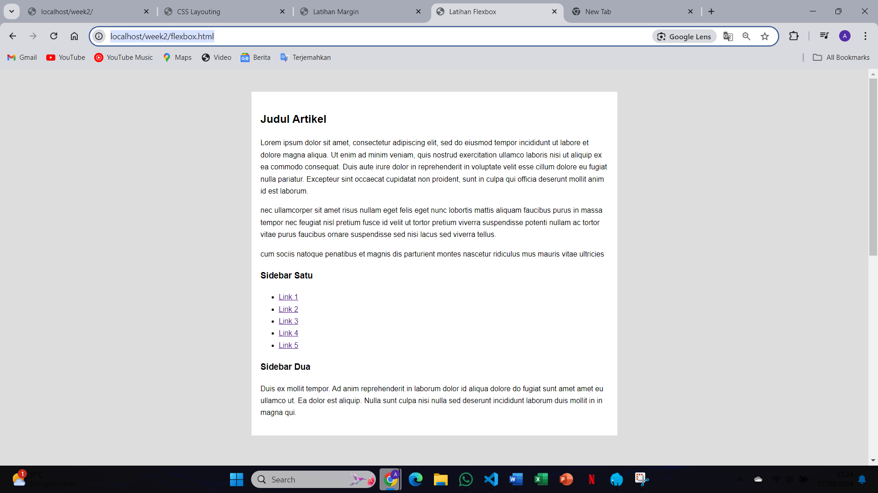After adding a style to the container-satu class and running the program, the flex container adjusts the layout of its child elements based on the new styles, such as alignment or spacing changes. If properties like justify-content or align-items were added, the child elements inside the container are repositioned accordingly, allowing for better control of horizontal or vertical alignment within the flexbox layout
11. 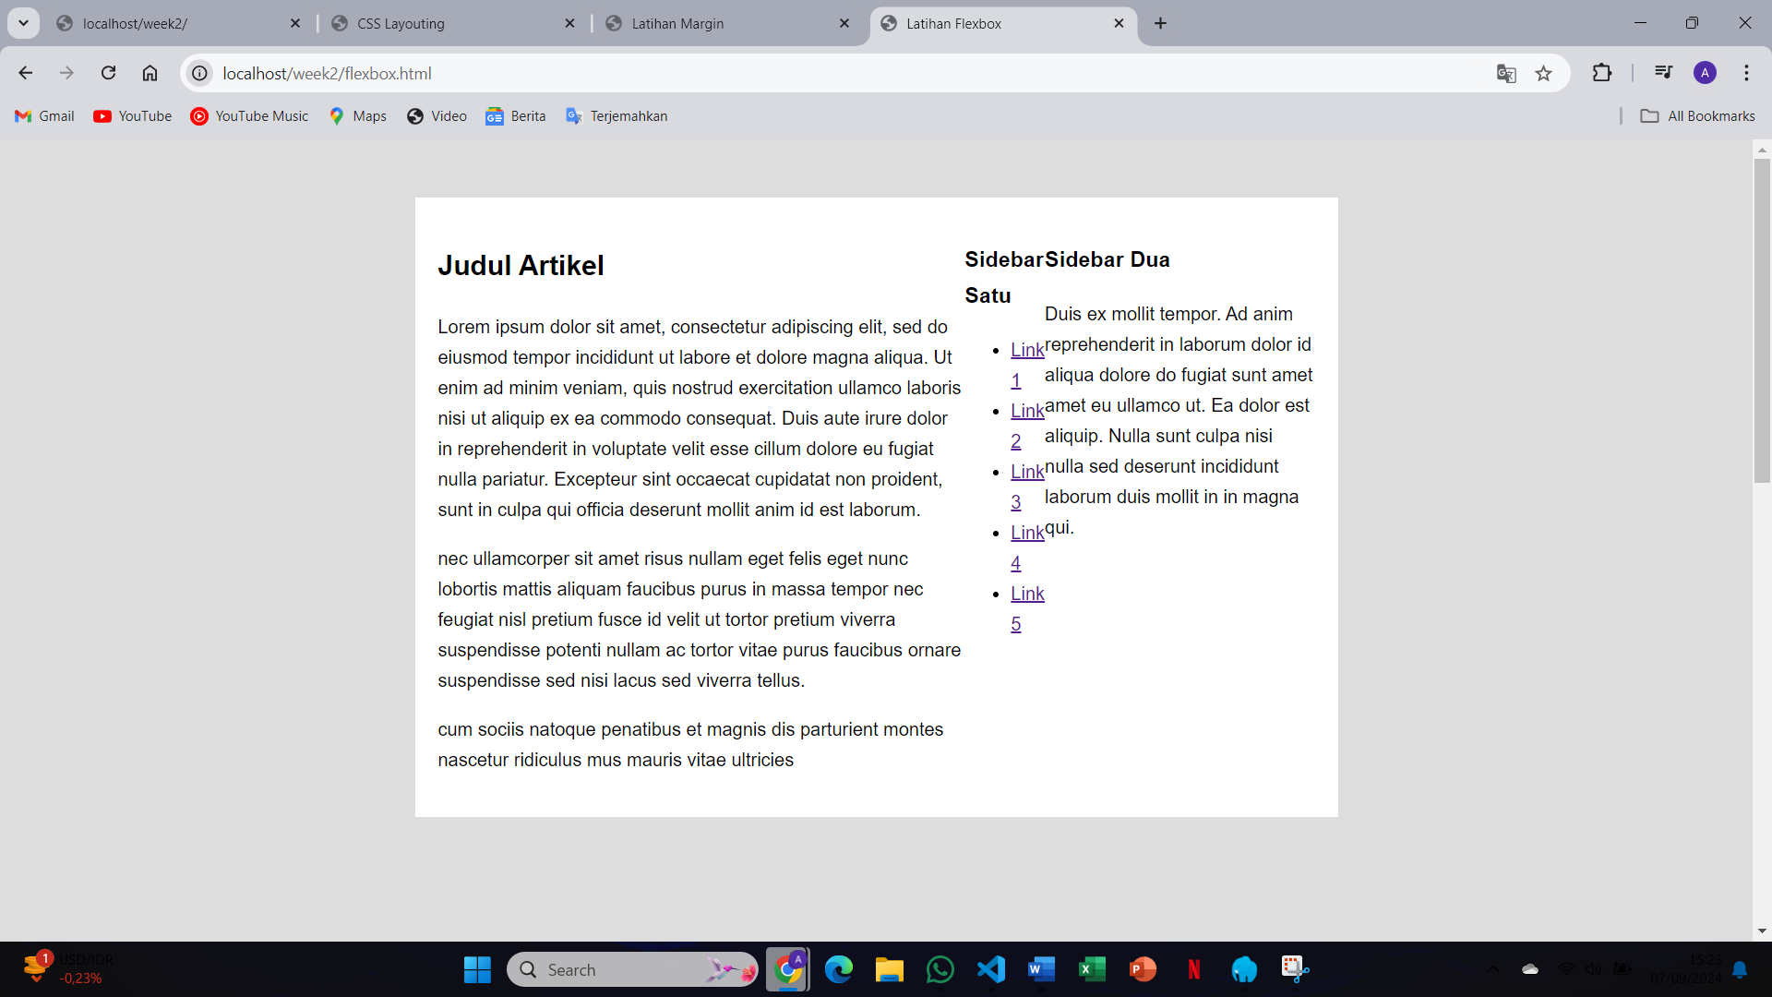After adding display: flex; to the container-satu selector and running the program, the child elements inside the container become flex items, aligning themselves along the main axis (either in a row or column) based on the flex properties. This allows for dynamic resizing and alignment of the items depending on the space available within the container, creating a flexible layout
12. 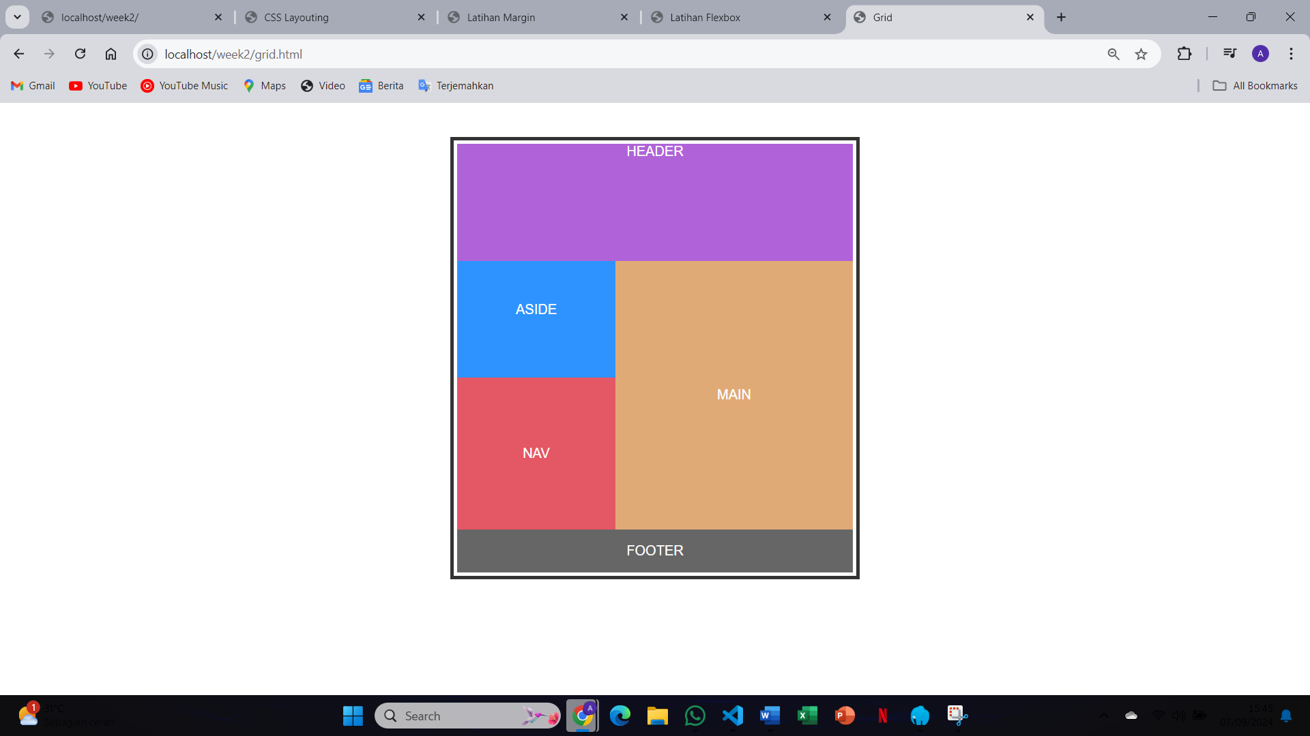After running the grid.html program, the elements inside the grid container are arranged into a structured layout based on the rows and columns defined by the grid properties. The grid items are placed into grid cells according to the specified grid-template-rows, grid-template-columns, and other grid settings, providing a well-organized, two-dimensional layout where items are aligned and spaced within the grid
13. 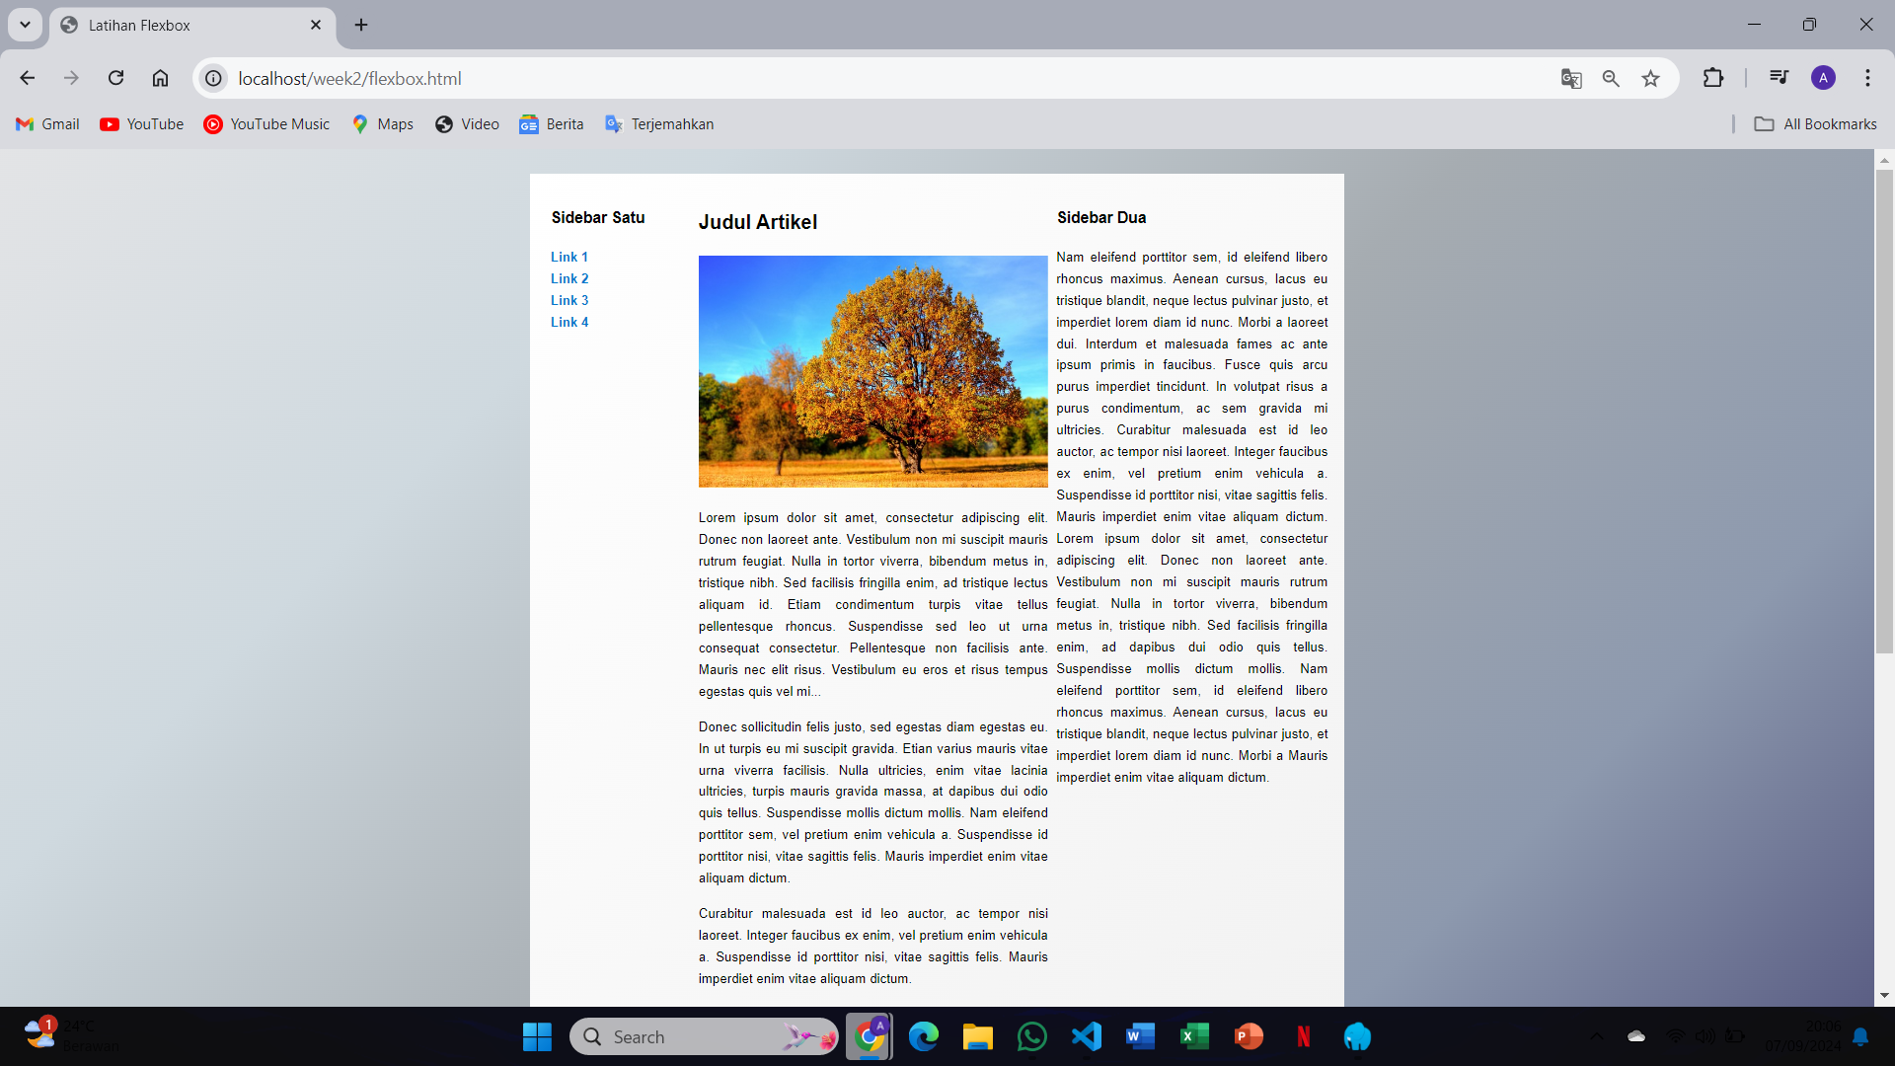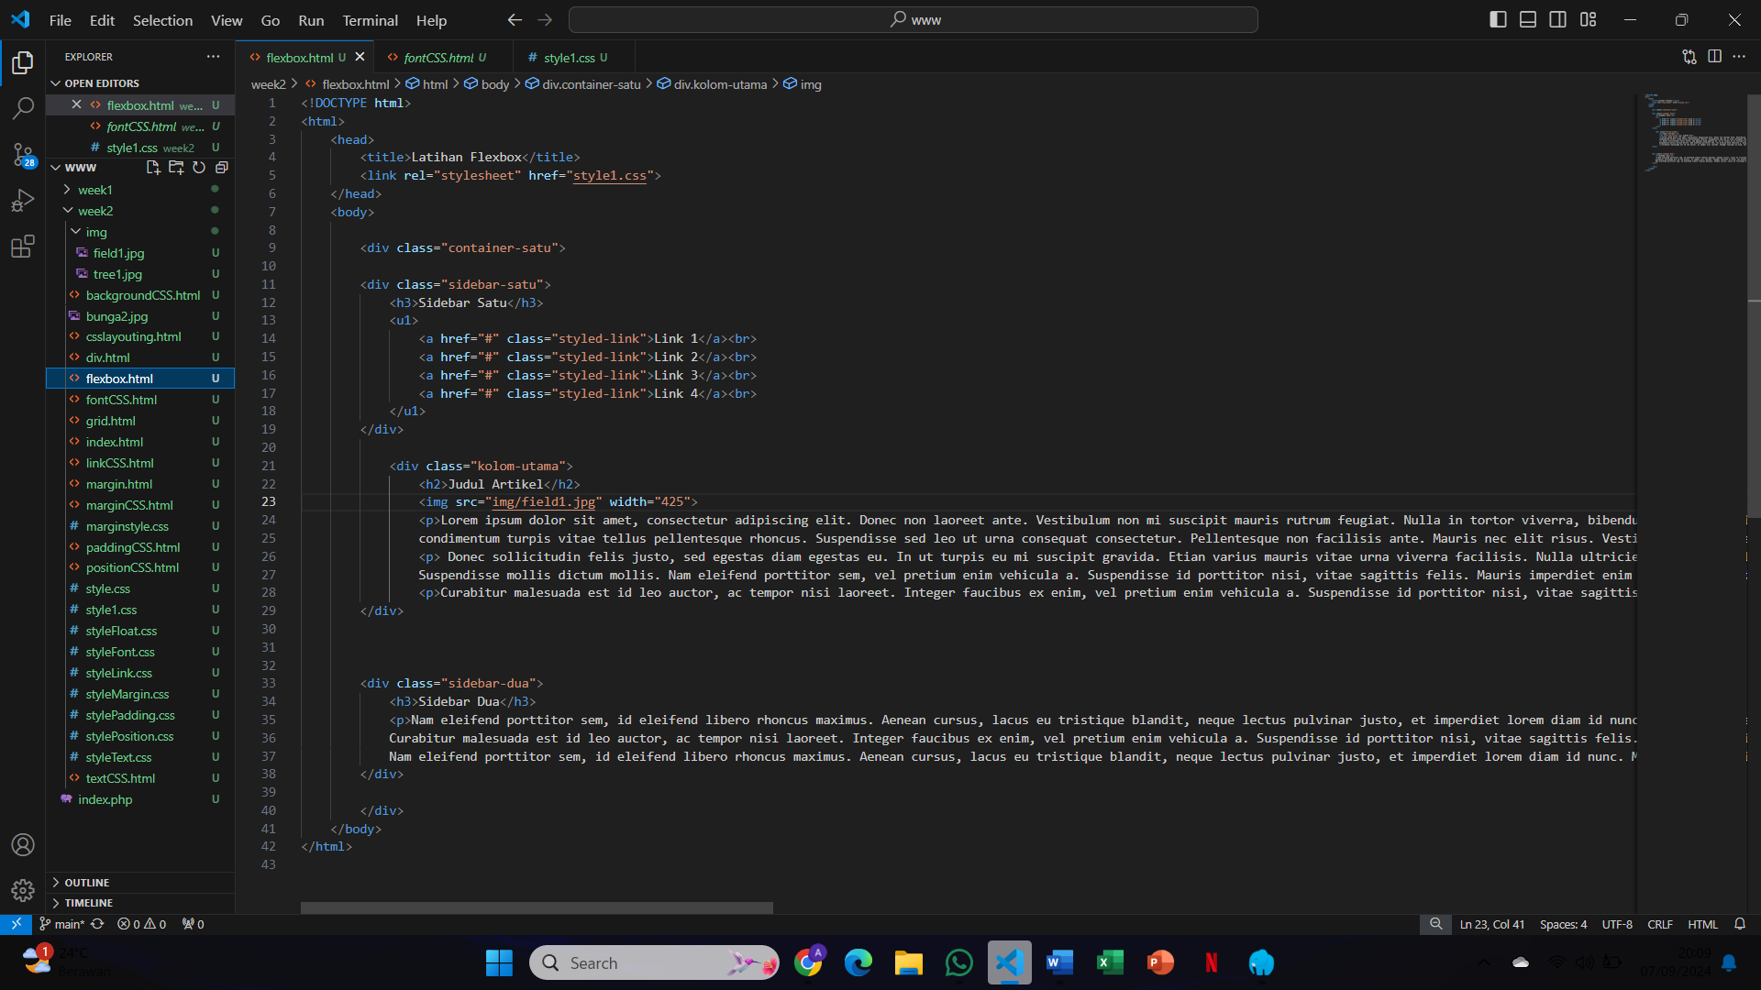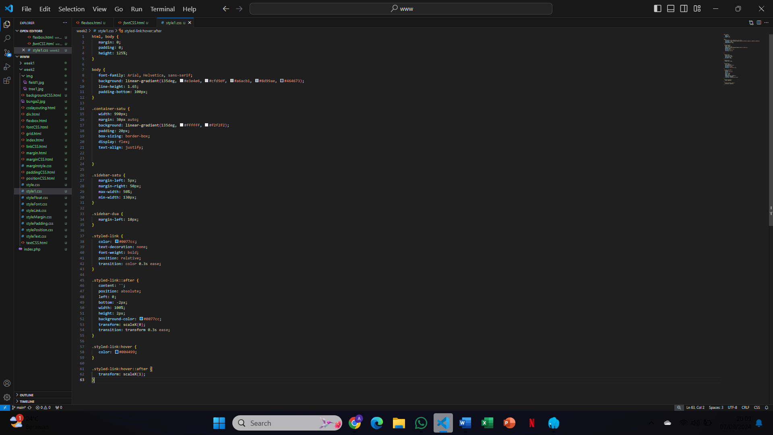After modifying the flex-box layout to include images and background colors, the flex items are displayed with the assigned images, and the background colors provide a more visually appealing design. The flex and order properties control the alignment and order of the items within the container, making the layout responsive and dynamic, with elements adjusting according to the screen size and container space

<https://github.com/adzinbrillian/DASPRO_WEB_SMT3/tree/main/week2>